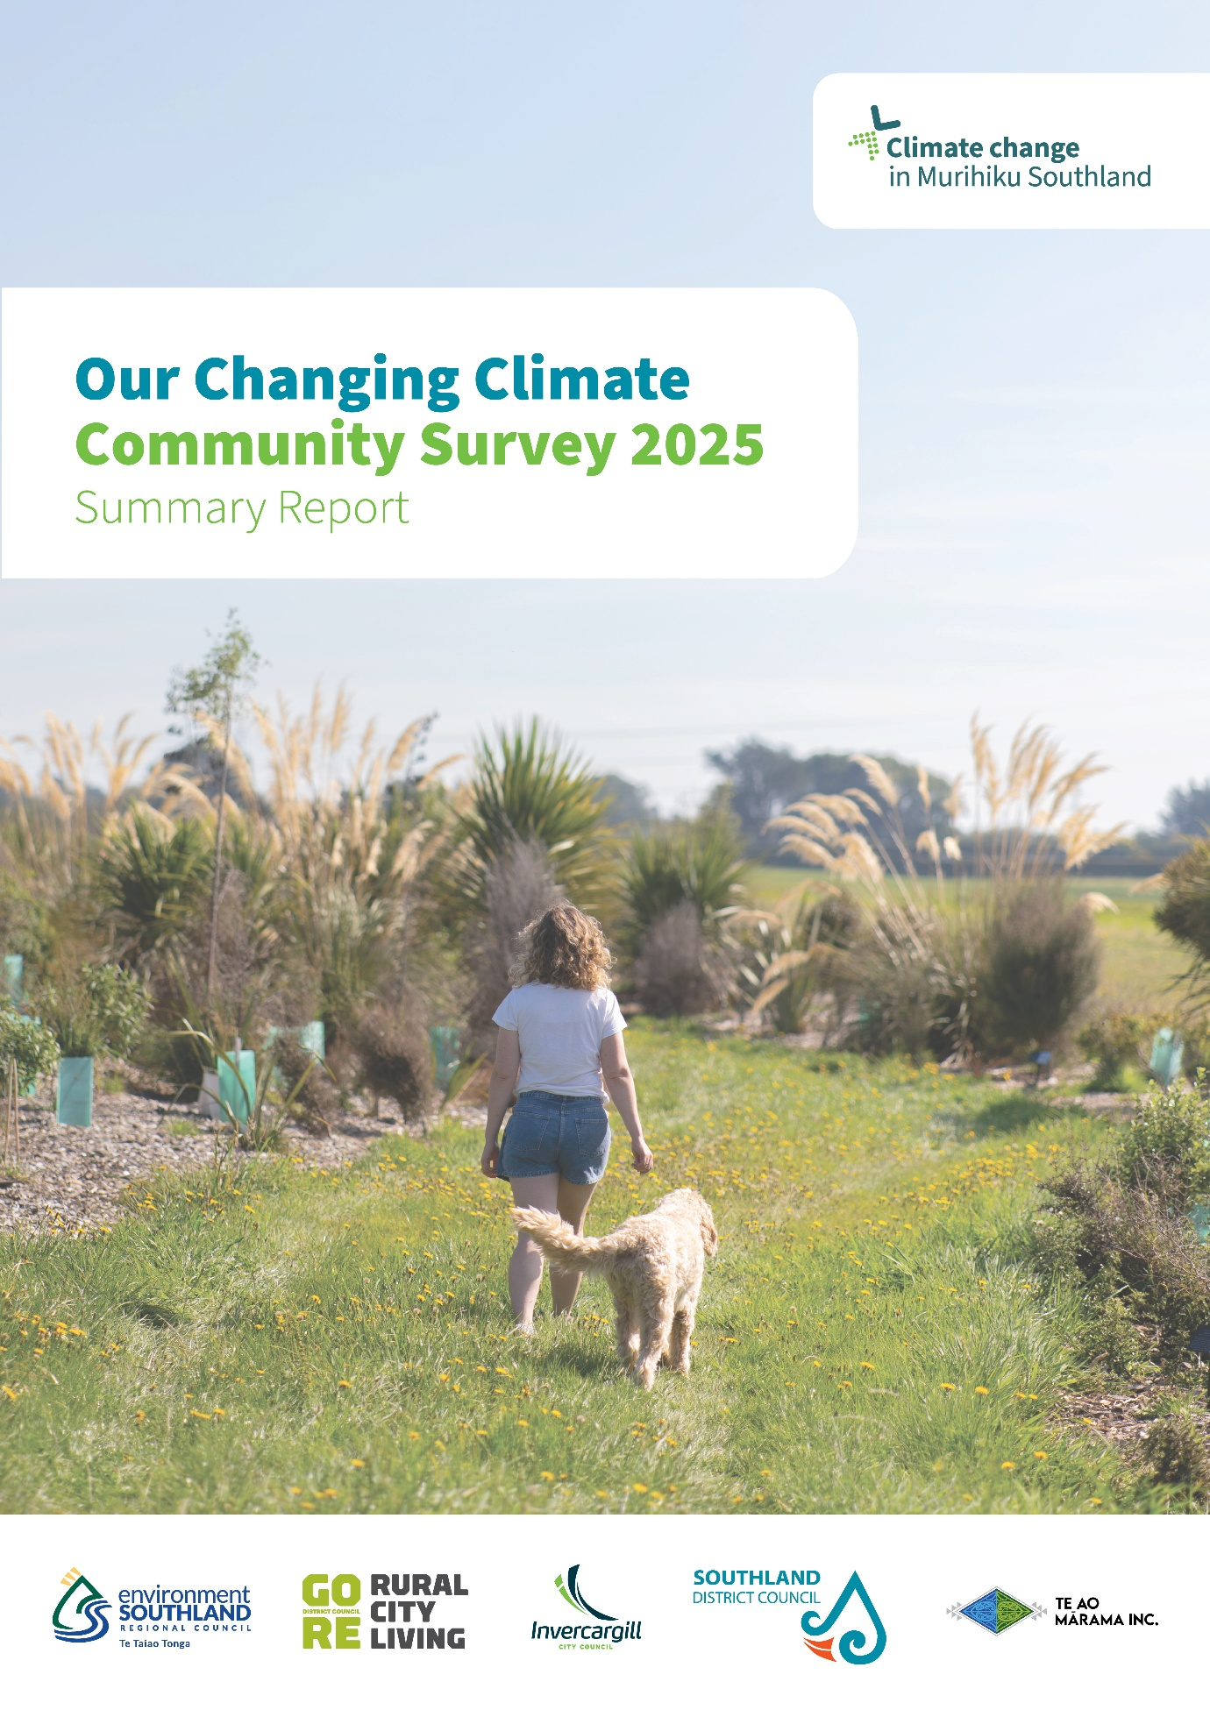

Contents
Report snapshot 2
1. Key Findings 3
2. Survey Context 4
3. Average Questions Score by Category 8
4. Topic Summaries 11

Report snapshot

Survey name
Our Changing Climate – Community Survey 2025

Survey dates
14 November 2025 – 8 December 2025

Survey goals
- Measure community awareness and concern about climate change impacts in Murihiku Southland.
- Identify preferred communication channels and engagement methods to guide future climate action planning.
- Assess preparedness levels, actions taken, and barriers to climate adaptation and mitigation among residents.

Key Findings

The Our Changing Climate – Community Survey 2025 provides a view of how people across Murihiku Southland perceive climate related change, their level of concern, and what encourages or discourages them to act.

About two‑thirds of respondents expressed concern about climate impacts (60% concerned about current impacts; 64% concerned about future impacts) and a similar proportion (63%) say they are prepared to change their behaviour to reduce their impact.

However, this concern and willingness is not matched by information engagement or confidence in community preparedness, highlighting a persistent concern – a preparedness gap: only 33% reported accessing information about local climate impacts in the past 12 months, and community preparedness was rated low (38%).

Just over half of respondents (53%) believe Environment Southland and other councils should be doing more to address climate issues and 55% of respondents are aware that Murihiku Southland has a Regional Climate Change Strategy (adopted 2024) and/or a Regional Framework for Action on Climate (adopted 2025). Confidence in the work being done by local government agencies to protect their community from the effects of a changing climate sits below the midpoint at 47%, highlighting expectations of councils are slightly higher than confidence levels.

Encouragingly, many residents report taking everyday actions to reduce their impact – particularly growing food (44%), reducing waste (43%), shopping locally (40%) and reducing household energy use (36%). Preparedness actions were less consistent: some people stored extra water/supplies (37%) or prepared an emergency kit (33%) while 28% reported taking no preparedness actions in the past year, reinforcing the low community preparedness result and highlighting uneven readiness across households.

The barriers for taking action are led by cost and structural constraints – cost of living (48%) and alternatives are expensive (41%) alongside limited transport options (31%). These constraints align with most common enablers for action – improved infrastructure (e.g. cycling paths and public transport 38%), followed by financial incentives (34%). Also, a quarter of respondents feel their actions do not make a difference (25%) and 10% selected that they don’t believe in a changing climate.

Respondents reported noticing more frequent storms and stronger winds (59%), seasonal shifts (50%), fewer frosts (45%), heavier rainfall events (41%), and less snow (38%), while 14% had not noticed changes. When asked what impacts they are most concerned about, the top priorities were disruption to infrastructure (41%), impacts on water quality and availability (30%), insurance availability/costs (28%) and more frequent or severe flooding (28%).
Finally, respondents’ communication preferences point to a blended approach. Social media (36%), email (26%), and council websites (22%) were the most preferred channels for climate information and involvement, complemented by online news (19%) and newspapers (18%).
Together, these results point to a clear set of opportunities for Murihiku Southland’s climate response: lift community preparedness, increase awareness of regional strategies and local risk information, and reduce practical barriers to action.

Survey Context

Purpose

Following a regional climate change hui in July 2022, Environment Southland and Te Ao Mārama, along with Gore District Council, Invercargill City Council and Southland District Council established the Regional Climate Change Working Group (RCCWG) to progress a regional response our changing climate in Murihiku Southland. As part of this work, Environment Southland undertook its first Murihiku Southland Climate Change Perceptions Community Survey in 2023, and repeated the survey in 2025 to understand how climate change is affecting people and communities, levels of awareness, and information needs.

The survey supports the implementation of the Regional Climate Change Strategy 2024 and the Regional Framework for Action on Climate for Murihiku Southland 2025. In line with Action 13.1 of the framework, the survey is repeated regularly to track changes in community awareness, concerns, and expectations over time. The first survey was conducted in 2023 and the second survey in 2025, with a biennial approach.

Method

The Our Changing Climate - Community Survey 2025 was conducted using a mixed methods online approach and ran from November 14 to December 8, 2025.

A total of 509 participants took part.

The estimated eligible voting population of the Southland Region, according to the New Zealand Electoral Office, was 80,984 as of the 30th of June 2024.

Based on this data and the number of survey responses, the overall data can be considered accurate to +/- 5.0% margin of error at the 95% confidence level.

Please note that:
- In certain cases, the sum of individual responses will not add up to totalled figures; this is due to rounding conventions.
- For the rating scale ‘strongly disagree to strongly agree’, agreement ratings were made on a 7-point Likert scale. Responses are reported as an average score and are scored as shown below.
- In some instances, small demographic groups were not covered in the demographic analysis of the data.
- Where small demographic groups were used to make observations about the results, these should be seen as observations and not conclusions, as the sample sizes could be too small to give any level of certainty or confidence.

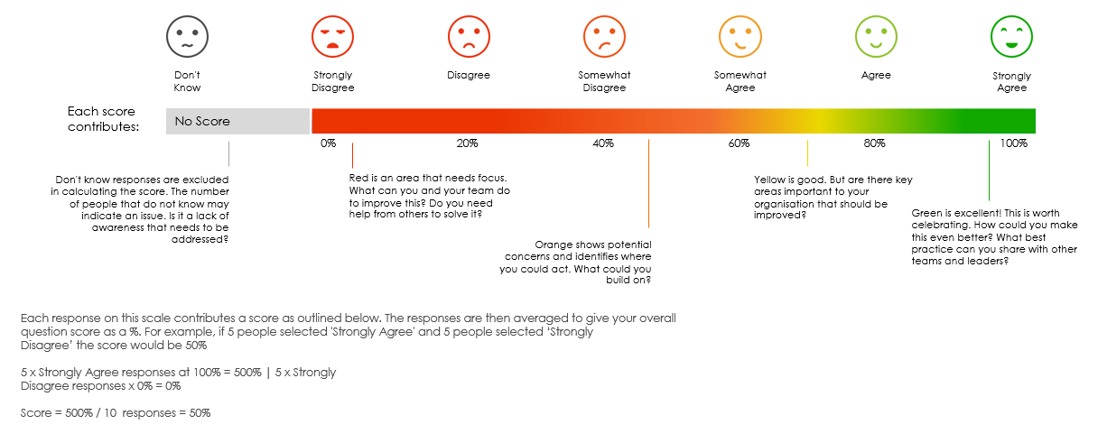

2.3 Participation by Demographics

The following tables show the responses achieved and the demographic information obtained, as well as the demographic information obtained in the last survey.

Participation

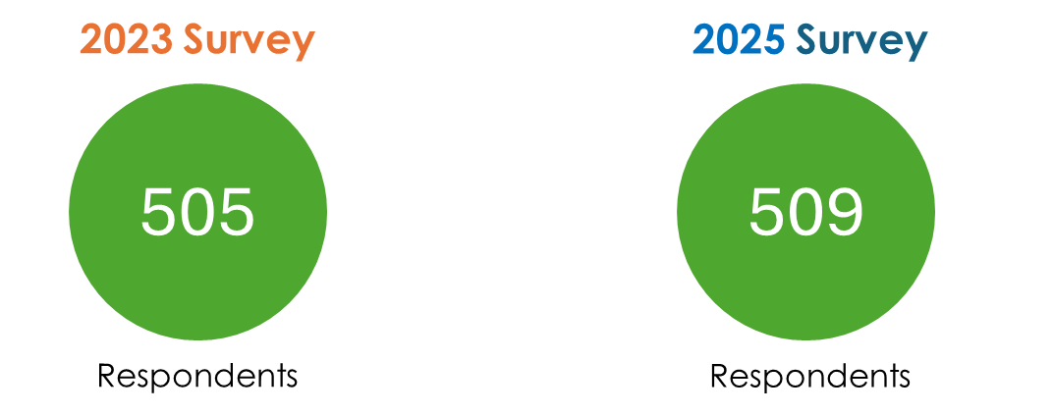

Demographics at a glance
- The majority of respondents were 26-65,398 (79%) in 2023 compared to 322 (63%) in 2025.
- 142 people aged +66 completed the survey in 2025 – compared to 86 in 2023.
- 28 people under 25 years completed survey in 2025 – compared to 10 in 2023.
- Gender split – approximately 50/50
- About 45% of respondents were from Invercargill (incl Bluff) in 2023, 50% in 2025
- About 16% from Gore in 2023, 16% in 2025
- About 39% from Southland in 2023, 34% in 2025
- 80% NZ European in 2023, 78% in 2025
- 11.5% Māori in 2023, 8.5% in 2025

- Respondent profile skewed older in 2025. There was a marked shift toward older respondents in 2025: 56+ years = 272 (2025) vs 190 (2023), alongside a decline in mid‑age groups 26–45 years = 114 (2025) vs 187 (2023).
- Youth participation improved (under‑18s: 13 vs 3 in 2023), suggesting improved reach to younger people, although the overall sample remains weighted to older residents.
- Geography remained broadly consistent, with Invercargill the largest respondent base (~48%); gender balance was close to even (about 49% female / 48% male).
- A large majority of respondents are long‑term locals: ~70% have lived in Southland 20+ years, indicating a community with deep local knowledge and investment in place.

By Age

By Gender

By Location

By Ethnicity*

By Length of Time

Average Questions Score by Category

These are a Strongly Agree – Strongly Disagree Likert scale question types

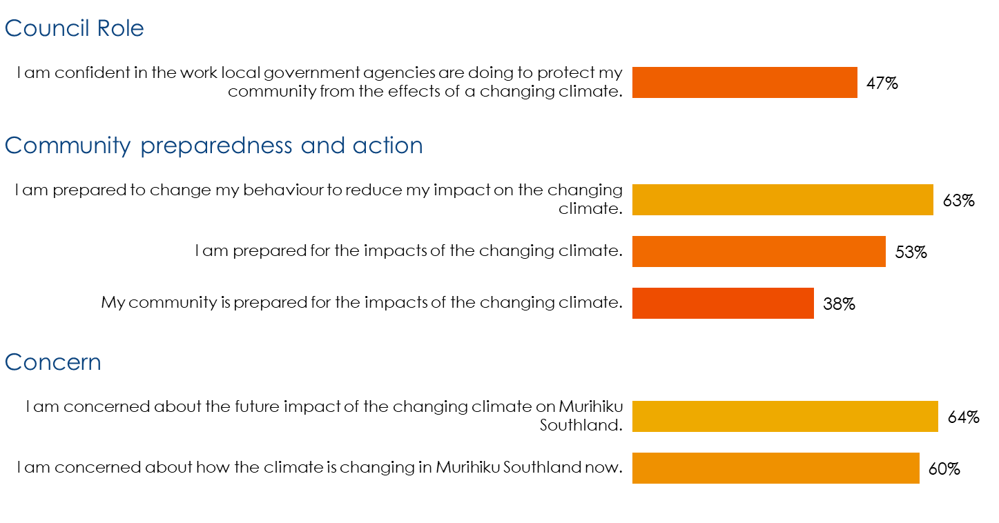
Perceptions

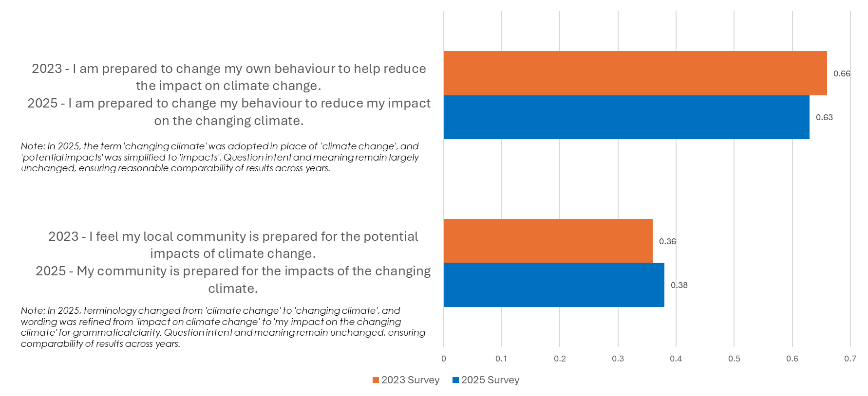
Comparison with 2023 Survey

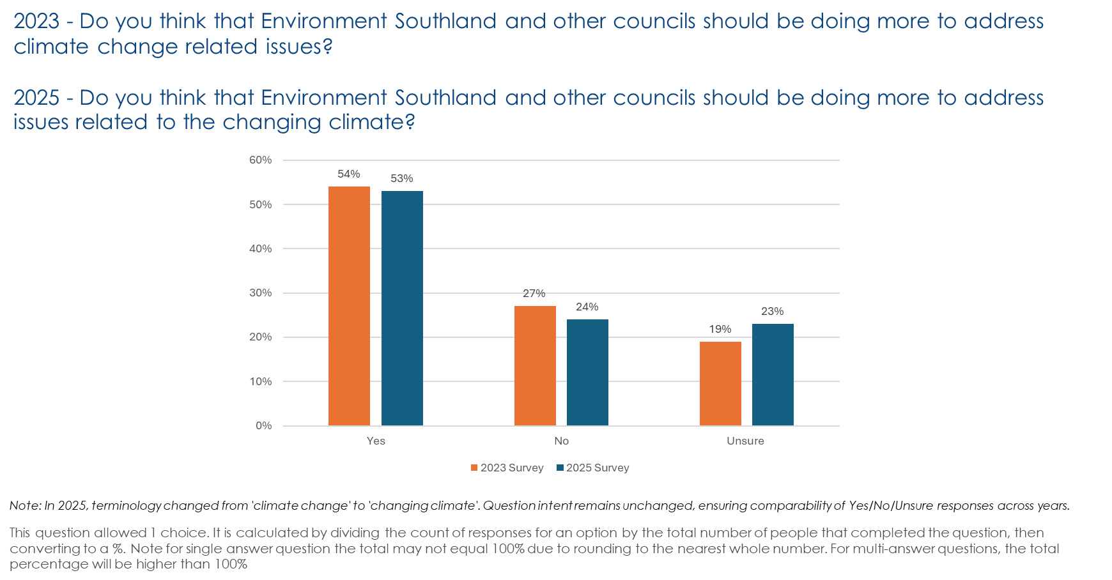

0-10 Question Scores
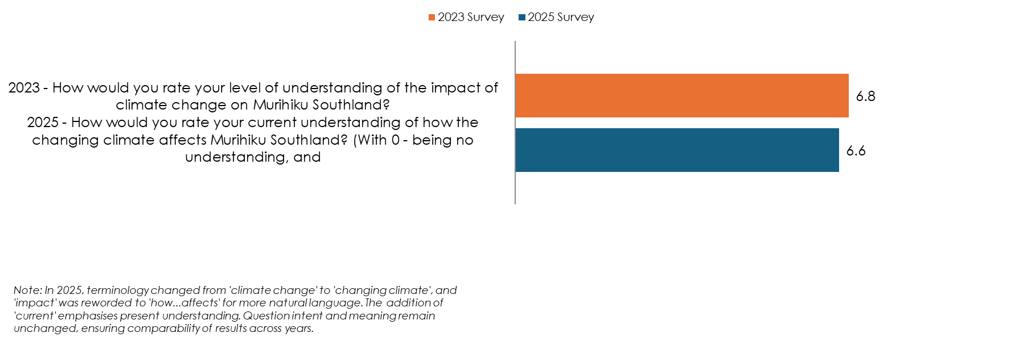

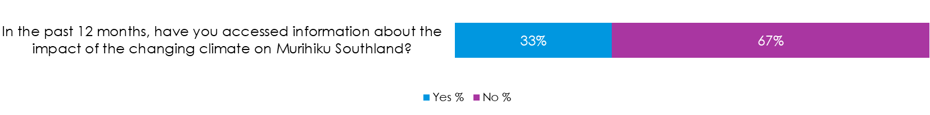
Community Awareness

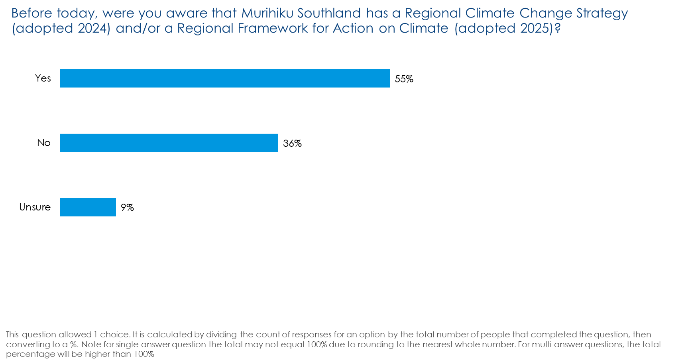

Topic Summaries

Which of the following potential impacts of the changing climate are you most concerned about in Murihiku Southland?

There were 57 comments provided. These can be grouped into the following common themes and topics.

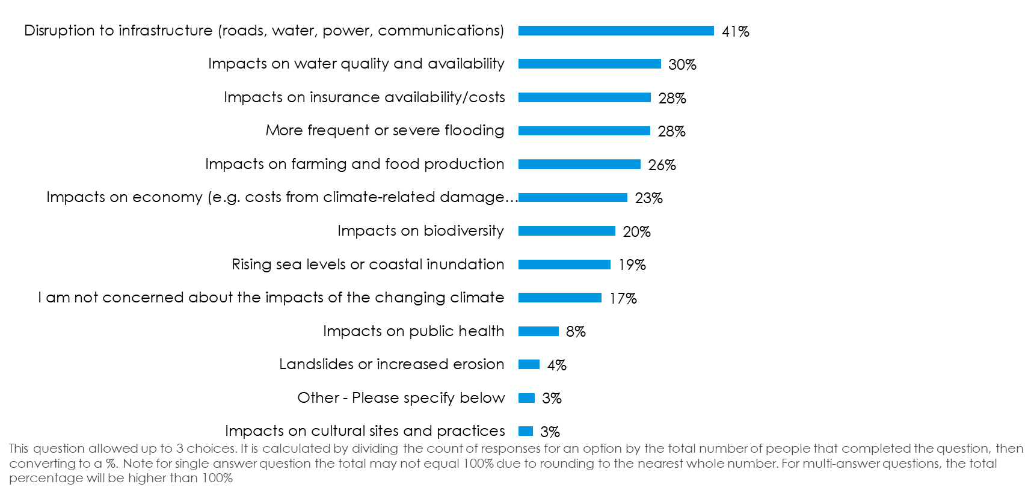

- ​Government Accountability: Participants expressed concerns about government accountability in managing climate impacts in Murihiku Southland. Some highlighted the need for better preparedness and resource allocation by emergency services to handle natural disasters like flooding. Others criticised local councils for allowing construction on floodplains, exacerbating flood risks. Concerns were also raised about government overreach, wasteful spending, and the focus on emissions over practical management of natural resources. Additionally, there was a call for more responsible and wise decision-making, avoiding actions based on ideology or virtue signalling.

- ​Biodiversity and Ecological Impacts: Participants expressed concern about the impact of climate change on biodiversity and ecological systems in Murihiku Southland. One participant highlighted the need for reforestation and pest management to protect forests for future generations. Another pointed out the negative effects of poor farming practices, such as draining effluent into rivers, which harm biodiversity. Concerns were also raised about the impact of planting pines near rivers on water quality and fish habitats. Additionally, some participants mentioned the broader ecological impacts, including rising sea levels and increased flooding, as significant worries.

- ​Social and Mental Health: Participants expressed significant concern about the social and mental health impacts of climate change in Murihiku Southland. Many highlighted the anxiety and stress caused by constant climate change discussions, particularly affecting young people. There is a worry about the broader effects on social cohesion and the stability of systems reliant on a stable climate. Some participants noted that while severe climatic events have always occurred, the ongoing dialogue about climate change can exacerbate mental health issues. Overall, there is a call for more comprehensive planning to adapt social systems to the changing climate.

- ​Survey Feedback: Participants expressed difficulty in limiting their concerns to just three potential climate impacts in Murihiku Southland. Many felt that all listed impacts were significant and deserved attention. Some participants specifically mentioned additional concerns such as impacts on biodiversity, rising sea levels, and more frequent flooding. The feedback suggests a need for the survey to allow more flexibility in selecting multiple concerns to better capture the participants' views.

- ​Flooding: Participants expressed concerns about flooding in Murihiku Southland, highlighting several key issues. Some believe that poor management of gravel buildup in rivers contributes significantly to flooding, rather than climate change itself. Others emphasised the need for local councils to address the problem of urban development on floodplains, which exacerbates flooding risks. Additionally, there is a call for better preparedness and resources for emergency services to handle flooding events effectively. Concerns also extend to the broader impacts of climate change, such as rising sea levels and biodiversity loss, which could increase flooding frequency.

- ​Cost of Living and Economic Impacts: Participants expressed concerns about the economic impacts of climate change in Murihiku Southland, particularly rising costs. They highlighted worries about increasing expenses such as mortgages, insurance, and utilities, which are exacerbated by climate regulations. Some participants noted that climate change discussions can lead to anxiety, especially among young people, and questioned the effectiveness of current climate management strategies. There is also a call for better management of natural resources, focusing on soil and water protection through regenerative practices.

- ​Emergency Preparedness: Participants expressed concerns about emergency preparedness in Murihiku Southland, highlighting the need for better-equipped emergency services and more comprehensive planning. There is a call for a shift in societal systems to adapt to climate change, rather than minor adjustments. The reliance on electricity and the need for backup plans were also noted. Additionally, specific concerns were raised about the adequacy of emergency services in the Tuatapere community and the risk of fire danger.

- Infrastructure: Participants expressed concerns about the impact of climate change on infrastructure in Murihiku Southland. Key issues include the construction of towns on floodplains, which exacerbates flooding problems. There is also worry about rising sea levels affecting critical facilities like rubbish tips and water treatment plants. Additionally, the heavy reliance on electricity for essential services highlights the need for backup plans to ensure resilience. Emergency services, particularly in remote areas like Tuatapere, are also a concern, indicating the need for improved infrastructure support.

- ​Environment: Participants expressed concerns about environmental impacts related to farming practices and land management. One comment mentioned farmers draining effluent directly into rivers, causing environmental damage. Another participant suggested planting more trees on farms to combat flooding and improve water and air quality. Additionally, concerns were raised about the impact of planting pines near rivers, which could affect water quality and fish habitats, and the broader implications of such practices on rural communities and landscapes.

- Climate Belief: A relatively small number of participants expressed scepticism about climate change, often attributing changes to natural cycles rather than human influence. Some comments highlighted a belief that climate change is exaggerated, citing historical climate variations like ice ages as evidence. Others criticised the focus on climate change, suggesting it causes unnecessary anxiety, especially among young people. There was also a call for better management of natural resources and infrastructure rather than focusing solely on emissions. Overall, the sentiment was that climate change is not a significant concern, with some participants questioning the validity of predicted impacts.

- ​Not concerned: Some participants expressing no concern about climate change impacts in Southland believe that the region's weather patterns have remained consistent over time. They argue that severe climatic events have always occurred and are part of natural cycles, citing historical examples like the Ice Age. Some participants feel that the focus on climate change creates unnecessary anxiety, particularly among young people, and that efforts to alter natural processes are futile. They emphasise the importance of common sense in dealing with natural events, such as not building in vulnerable areas.

In the past 12 months, have you accessed information about the impact of the changing climate on Murihiku Southland?

There were 114 comments provided. These can be grouped into the following common themes and topics.

- Environment Southland (ES): Participants have accessed information about the impact of climate change on Murihiku Southland through various sources. Many have used the Environment Southland website for climate change predictions and research studies. Others have relied on Environment Southland's website and flood mapping resources. Some participants have also utilised media outlets, national and international publications, and attended seminars and conferences. Additionally, newsletters and community discussions have been valuable for staying informed.

- ​Media: Participants have accessed information about the impact of climate change on Murihiku Southland through various media sources. Many mentioned reading newspaper articles and online news platforms like ODT and Stuff. Social media, including Facebook, was also a common source, although some participants specified using scholarly sources. Additionally, local publications such as the Southland Express and brochures from events like EcoFest were noted. Some participants also mentioned attending seminars and community meetings, and accessing information from government websites.

- ​Work, Industry and Education: Participants have accessed information about the impact of climate change on Murihiku Southland primarily through their work and educational activities. Many mentioned workplace workshops and presentations as key sources of information. Some participants highlighted the use of online resources, including websites and publications from national and international research institutes. Others gained insights through involvement in local environmental groups and attending conferences related to their professional roles. Additionally, educational programs and seminars were noted as valuable for understanding climate change impacts in the region.

- Online: Participants have accessed information about the impact of climate change on Murihiku Southland primarily through online sources. Many have read articles on the internet, while others have used websites, including those of environmental groups and government reports. Some have also engaged with community action plans and exchanged information with international groups. Additionally, coastal maps and personal research have been utilised to understand the changing climate.

- ​NIWA and Research Agencies: Participants have accessed information about the impact of climate change on Murihiku Southland through various organisations and research agencies. NIWA is frequently mentioned, with participants citing its sea level modelling and online resources. Other sources include government organisations like the Ministry for the Environment (MfE) and local councils such as the Southland District Council (SDC). Additionally, participants have referred to academic publications, conferences, and reports from national and international research institutes to stay informed about climate change impacts in the region.

- ​Councils and Regional Working Group: Participants have accessed information about climate change impacts through various channels, including council and government websites, regional reports, and climate strategy consultations. Some have attended events like the Climate Collaboration Hui or engaged with regional climate change working groups. However, there are concerns about transparency and accessibility of information, with some participants feeling that information should be more openly shared, especially by local councils. Others have used online resources to research specific topics like sea level rise and carbon footprints.

- Community and Family: Participants have accessed information about the impact of the changing climate on Murihiku Southland through various community and family channels. Many rely on local media, such as newspapers and radio programs, to stay informed. Some participants engage with community groups and events, like Thriving Southland and local catchment groups, to discuss climate issues. Others gather insights from family members or colleagues involved in environmental work. Additionally, online resources and newsletters, such as those from the QEII Trust, provide valuable information. These diverse sources highlight the importance of community and family networks in understanding climate impacts.

- ​Central Government: Participants have accessed information about the impact of climate change on Murihiku Southland through various sources. Central government reports, such as those from the Ministry for the Environment (MfE), are frequently mentioned. Many participants also refer to government websites and publications for detailed insights. Additionally, some have used academic and scholarly sources, including national and international publications, to understand the broader context of climate change impacts. Social media and local council websites are also utilised for gathering information.

- ​Social Media: Participants have accessed information about the impact of climate change on Murihiku Southland through various social media platforms. Some rely on social media for scholarly sources, while others combine it with news media and government websites. Social media is often used alongside traditional media like newspapers and official government information to stay informed. Additionally, some participants use social media to observe discussions and updates from local councils and environmental monitoring.

- Maps: Participants accessed various online resources to understand the impact of climate change on Murihiku Southland. Some explored coastal maps showing changing high tide lines, while others used science portals and web maps for broader insights. University projects also involved mapping climate change and sea level rise, focusing on the South Island. Additionally, participants looked up flood zones and examined predicted sea level rise maps, often using government websites and news articles for information.

- ​Southland District Council (SDC): Participants have accessed information about the impact of the changing climate on Murihiku Southland through various sources associated with the Southland District Council (SDC). Some attended workshops organised by the SDC, while others watched online presentations by different organisations to the SDC. Additionally, information was gathered from other entities like Environment Southland (ES), the Ministry for the Environment (MfE), and other organisations.

What are the best ways for us to inform you about and/or involve you in Murihiku Southland’s response to a changing climate?

There were 45 comments provided. These can be grouped into the following common themes and topics.

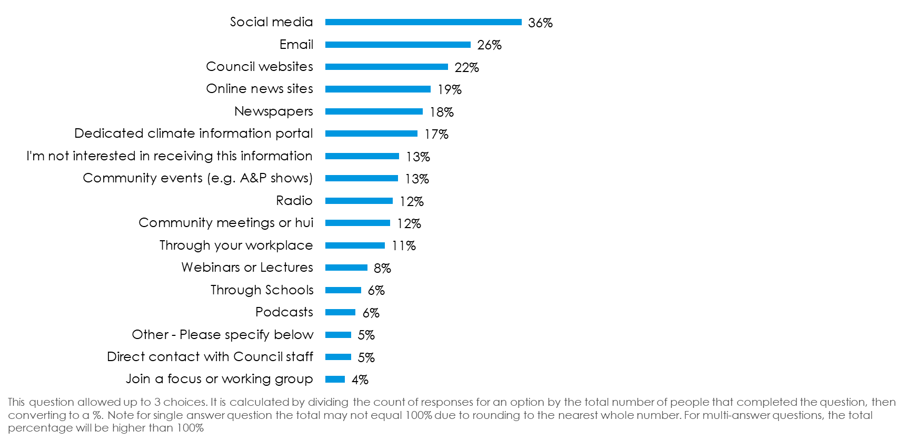

- Communication Channel Preferences: Participants suggested a variety of communication channels to stay informed about Murihiku Southland’s climate response. Many highlighted traditional methods like mail to letterboxes and the Southland Express newspaper, which is widely distributed and free. Others recommended modern approaches such as podcasts and a dedicated climate emergency portal. Some participants emphasised the importance of using multiple outlets, including television, radio, social media, and community meetings, to reach diverse audiences effectively.

- ​Climate Change Belief: The comments reflect a strong scepticism towards climate change among a relatively small number of participants. Some believe that climate change is not a real issue, describing it as a hoax or a non-problem. Some participants argue that climate change is a natural occurrence and not influenced by human activities, citing historical weather patterns as evidence. There is also a sentiment that efforts and resources spent on addressing climate change are misguided and wasteful. Participants express a desire for transparency and truth in communications about climate change, suggesting that current narratives are misleading.

- ​Trust and Credibility: Some participants expressed a lack of trust in the information provided by local authorities regarding climate change. Many prefer to conduct their own research, citing concerns about bias and outdated science. Some participants mentioned specific scientists, like William Happer, as credible sources for climate change information. There is a strong desire for transparency and access to all evidence, rather than being told to 'follow the science' without context. Overall, participants are sceptical of the current messaging and seek more balanced and comprehensive data.

- ​Financial and Ratepayer Concerns: Participants expressed significant concerns about financial management and the use of ratepayer funds in addressing climate change in Murihiku Southland. Some believe that resources are being wasted on what they perceive as unnecessary initiatives, with some labelling the efforts as a 'scam' or 'hoax'. There is a strong sentiment that funds should be directed towards more immediate local issues rather than climate change. Additionally, participants emphasised the importance of using cost-effective communication methods to avoid further expenditure of ratepayer money.

- ​Do not want Information: Several participants expressed a preference for not receiving information about Murihiku Southland's climate response. Some prefer to conduct their own research, feeling well-informed about climate change issues. Others distrust the information provided by the regional council, citing outdated science and incorrect models as reasons for their scepticism. Additionally, there is a sentiment that the council should focus on prioritising community needs rather than attempting to control uncontrollable climate factors.

- ​Community Engagement: Participants suggest various methods for effective community engagement regarding Murihiku Southland’s climate response. Some emphasise the importance of open discussions and transparency, advocating for access to comprehensive information rather than one-sided narratives. Community meetings, hui, and working groups are recommended as effective platforms for engagement, alongside the use of radio, social media, and educational institutions. Involving local personalities and integrating climate programmes into schools are also seen as impactful strategies to raise awareness and encourage participation.

- ​Other Priorities: Participants expressed diverse priorities regarding climate change responses. Some emphasised the need for the regional council to focus on practical community needs, such as managing gravel build-ups and wilding pines, rather than climate initiatives perceived as uncontrollable. Others suggested practical measures like establishing strategic fuel reserves, modern flood protection, and promoting afforestation. Additionally, there was support for investing in small-scale renewable energy solutions, such as rooftop solar on public buildings and small wind systems. A dedicated climate emergency portal was also proposed to address climate and pollution issues.

- ​Communication Barriers: Some participants highlighted several communication barriers in Murihiku Southland's climate response efforts. One participant noted that while emails are read, they are often overwhelming due to the volume of information received daily, suggesting that emails may not be the most effective platform. Another participant mentioned the limited radio access in Tuatapere, indicating a need for alternative communication methods in certain areas. Additionally, concerns were raised about the wastefulness of printed materials, which sometimes end up discarded, suggesting a preference for more sustainable communication methods.

- ​Education: Participants suggest using a variety of methods to educate and involve the community in climate response efforts. They recommend leveraging multiple outlets to cater to different groups, such as community meetings, radio, social media, and educational institutions like schools and universities. Some participants highlight the effectiveness of involving local personalities and creating school programs to engage both students and their families. While emails are mentioned, they are noted as less effective due to information overload.

What are your biggest barriers to taking action to reduce your impact on the changing climate and/or to prepare for its effects?

There were 89 comments provided. These can be grouped into the following common themes and topics.

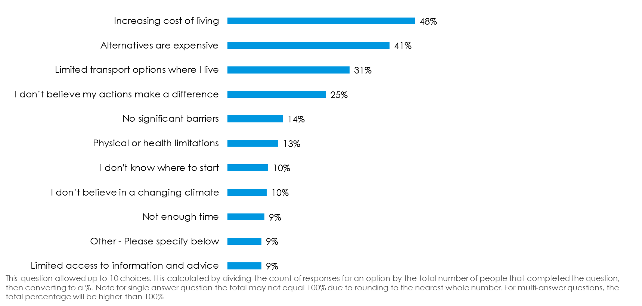

- Individual Action: Participants expressed frustration over the perceived ineffectiveness of individual actions in combating climate change, citing the need for collective action and government leadership. Many feel disillusioned due to the lack of significant changes by major polluting nations and corporations. Financial constraints and the impracticality of certain eco-friendly options, like electric vehicles, were also mentioned as barriers. Some participants believe that climate change is a natural phenomenon and question the impact of human actions. Overall, there is a call for broader systemic changes rather than relying solely on individual efforts.

- Government Accountability: Participants expressed frustration with government accountability in addressing climate change. Many believe that government decisions, such as not prioritising climate change and wasteful spending, hinder progress. Some feel that the lack of commitment from both local and international governments makes individual efforts seem insignificant. Others highlight the need for political consensus and effective policies to drive meaningful change. There is also concern about the influence of big businesses and the perceived lack of transparency in climate-related information provided by governments.

- Cost and Affordability: Participants identified cost and affordability as significant barriers to taking climate action. Many noted the high expenses associated with green energy options, such as solar panels and electric vehicles, which are not financially accessible for everyone. There is also concern about government and council decisions that do not support affordable climate solutions. Some participants highlighted the need for more incentives and support to make sustainable choices feasible. Additionally, the lack of affordable alternatives and shared information networks was mentioned as a hindrance to taking effective climate action.

- Structural and Situational Constraints: Participants identified several structural and situational constraints that hinder their ability to reduce their climate impact. Many face limitations due to their living situations, such as renting homes where they cannot make modifications like installing solar panels. Others mention the lack of public transport options, especially in rural areas, making it difficult to reduce reliance on cars. Financial constraints also play a role, with some unable to afford eco-friendly alternatives like electric vehicles. Additionally, workplace policies, such as resistance to remote work, and time constraints limit their ability to implement climate-friendly practices.

- Education and Engagement: Participants highlighted several barriers to taking action on climate change, focusing on education and engagement. A common issue is the lack of accessible and relevant information, especially for those in rural areas, which makes it difficult to take effective action. Some participants noted the absence of shared platforms for exchanging ideas and resources, which could foster community engagement and awareness. Additionally, there is a perceived lack of role models and leadership from influential figures, which discourages individual efforts. Finally, the high cost of sustainable alternatives and the prevalence of misinformation were also mentioned as significant obstacles.

- Policy and Regulation: Participants identified several policy and regulation barriers hindering climate action. Local council rules, such as restrictions on installing water tanks for grey water use, were mentioned as obstacles. Outdated legislation, particularly concerning scientific advancements like gene editing, also limits progress. Compliance requirements and permissions were noted to slow access to new technologies. Some participants highlighted the need for better government policies and leadership, suggesting that current policies often favour wealthy sectors. There is a call for political consensus and bipartisan policies, with an emphasis on public consultation to drive effective climate action.

- Global Action: Participants express frustration over the lack of global action on climate change, highlighting that efforts by individuals or smaller nations like New Zealand seem insignificant when major polluting countries and multinational corporations continue to increase emissions. There is a sentiment that global cooperation and commitment, especially from large economies like the US, Russia, and China, are essential for meaningful progress. Some participants feel disillusioned by the perceived ineffectiveness of international agreements like the Kyoto and Paris accords, and suggest that research into climate impact amelioration might be more beneficial than prevention efforts alone.

- Trust: Some participants expressed a lack of trust in the information provided about climate change. Some believe that the narrative is manipulated by governments and media to fit certain agendas, rather than presenting the truth. There is a perception that climate models and reports are biased, influenced by those funding the research. Additionally, some participants feel that local councils and organisations are undermining genuine environmental efforts, further eroding trust.

- Leadership: Some participants expressed concerns about the lack of leadership in addressing climate change. Many feel that without government leadership and collective action, individual efforts seem impractical. There is a perception that councils and central government are not prioritising climate change, with some suggesting that policies favour wealthy sectors. The absence of role models and leaders who 'walk the talk' further discourages action. Additionally, the affordability of green energy options and the high cost of low-emission vehicles are seen as barriers, exacerbated by the lack of supportive policies.

- Environment: Some participants identified several barriers to taking action on climate change. One major concern is the inefficiency and lack of support from government and local bodies, which are perceived as wasting resources rather than aiding environmental efforts. Additionally, there is frustration with big businesses, which are seen as corrupt and detrimental to rural communities by pushing through projects like wind farms without proper consent. Despite these challenges, some participants express support for initiatives like forest restoration and predator control as positive steps towards environmental conservation.

- Climate Belief: A relatively smaller number of participants expressed scepticism about the human impact on climate change, with some viewing it as a natural, historical process. Several comments highlighted a belief that climate change narratives are driven by political or financial agendas rather than scientific evidence. Others mentioned that while they acknowledge climate change, they doubt the extent of human influence and are critical of the emphasis on CO2 emissions. A few participants suggested that climate change is used to instill fear or control, questioning the motives behind the climate change discourse.

Which actions have you taken in the past 30 days to reduce your impact on the changing climate?

There were 74 comments provided. These can be grouped into the following common themes and topics.

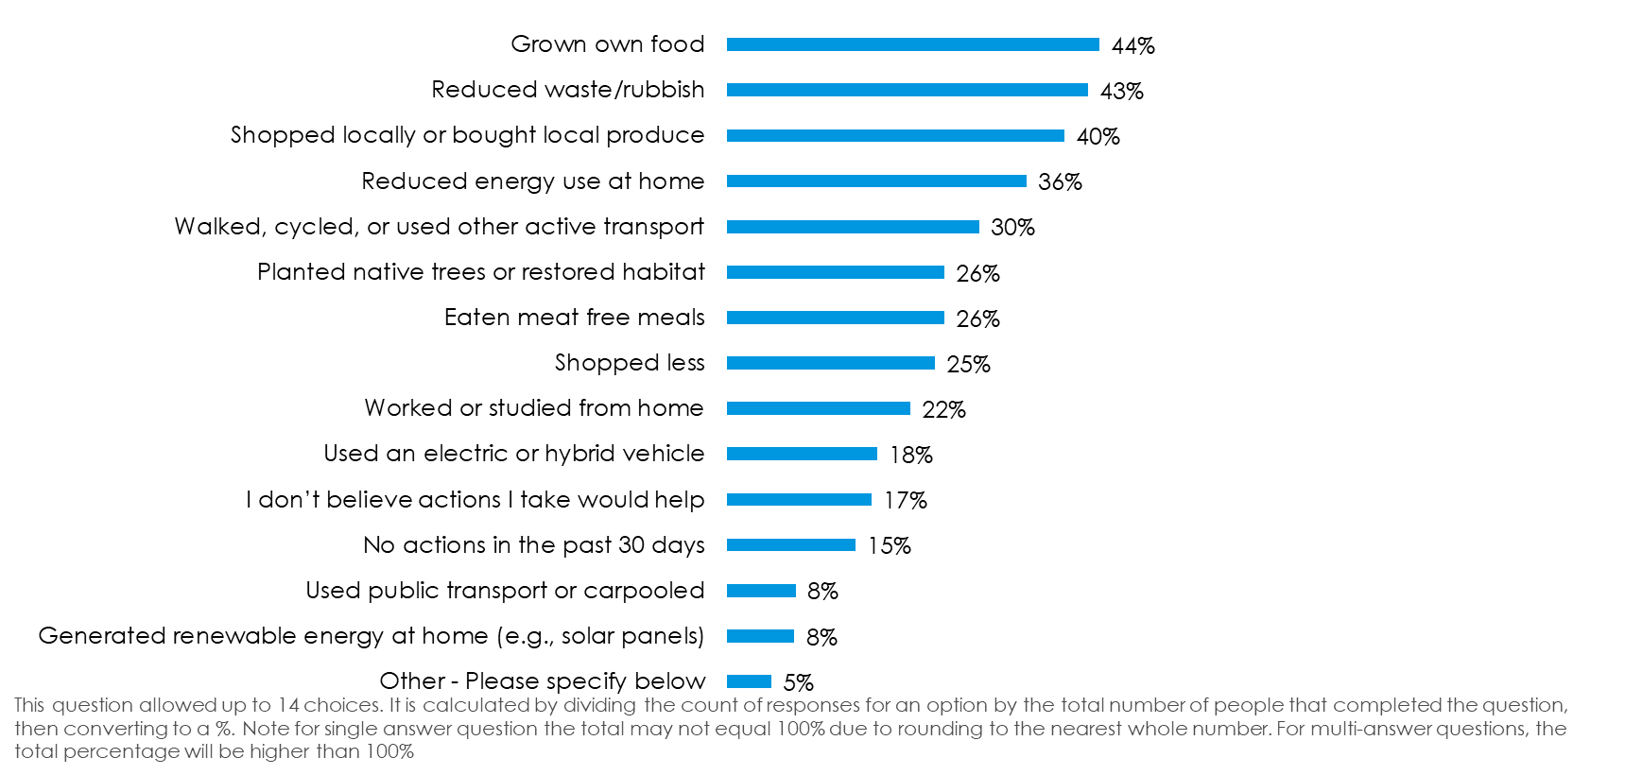

- Food: Participants expressed strong opinions on the relationship between food choices and climate change. Some argued that reducing meat consumption does not significantly impact climate change, citing the economic importance of meat production and questioning the effectiveness of alternative food options. Others mentioned practices like growing their own food and reducing dairy intake as ways to lessen their environmental impact. There was also criticism of promoting meat-free meals, with some viewing it as misinformation or greenwashing, while a few participants highlighted the environmental benefits of vegetarian diets.

- Transport: Participants have taken various actions to reduce their transport-related impact on climate change. Some have increased the use of virtual meetings, like Zoom, to minimise travel. Others have adopted strategies such as consolidating errands into fewer trips and purchasing e-bikes to reduce car usage. A few participants have limited their car use to once a week or tried to use their cars less frequently. However, some face challenges due to the lack of public transport options in their areas, which limits their ability to reduce reliance on personal vehicles.

- Other Motivations for Actions: Several participants indicated that their actions to reduce climate impact are motivated by factors other than climate change. Some mentioned that they engage in sustainable practices to avoid wastage or save money rather than due to environmental concerns. Others highlighted that their lifestyle choices, such as growing their own food or being self-sufficient, are driven by economic reasons or personal preferences. Additionally, some participants expressed scepticism about climate change narratives and emphasised the importance of conducting their own research.

- Structural and Situational Barriers: Participants highlighted several structural and situational barriers to reducing their climate impact. Many noted the lack of public transport in their areas, making it difficult to avoid using personal vehicles. Some mentioned financial constraints, such as the high costs of solar power and electric vehicles, which limit their ability to adopt more sustainable practices. Others pointed out that their workplaces do not support flexible work arrangements, which could help reduce emissions. Additionally, there is frustration over the lack of meaningful action from larger industries and countries, which participants feel undermines individual efforts.

- Consumption: Participants have taken various actions to reduce their consumption impact on the climate. Some have opted to buy secondhand goods instead of new items, highlighting a preference for reusing products. Others have focused on growing their own food and using resources wisely, a practice maintained for many years. Additionally, participants have shared vehicle use and reduced their overall purchases. There is also a call for increased recycling efforts to manage waste better and reduce the use of plastics in everyday items.

Survey Feedback: Some participants expressed strong dissatisfaction with the survey, criticising it for being poorly designed and containing leading questions. Some comments highlighted the perceived hypocrisy of promoting actions like reducing meat intake, given the economic reliance on meat production. Others noted practical constraints, such as lack of space or financial means, that limit their ability to adopt climate-friendly practices.
- Land and Environmental Stewardship: Participants have taken various actions to reduce their environmental impact. Some have focused on pest control, targeting species like deer and possums, to help native forests thrive. Others have planted a significant number of trees and used low methane genetic rams to lower emissions. Additionally, efforts include replacing ornamental trees with fruit and nut trees, installing rainwater tanks, and improving energy efficiency. These actions reflect a commitment to land and environmental stewardship, with some participants noting that such practices have been part of their lives for many years.

- Education and Engagement: Participants have taken various actions to educate and engage others about climate change. Some have focused on raising awareness through research and encouraging public and organisational strategies. Others have promoted sustainable practices, such as waste reduction, within their workplaces and social circles. Additionally, educating children and friends about reducing their environmental footprint has been a priority for some participants.

- Government Accountability: Participants expressed concerns about government accountability in addressing climate change. One participant criticised the focus on individual actions, suggesting that government incentives and penalties, like subsidies for electric vehicles and taxes on high-emission vehicles, are more effective. Another participant questioned the justification for increased environmental rates. There was also criticism of local councils for not delivering services within budget, suggesting that surveys may be used to justify unnecessary spending. Lastly, a participant argued that households have limited impact on climate change, emphasising the role of industries and politics, and suggesting voting as a means to influence legislative change.

- Energy: Participants have taken various actions to reduce their energy impact on the climate. One participant mentioned the installation of solar panels as a future plan. Another is exploring the costs associated with personal renewable energy generation. Additionally, some participants are critical of electric cars due to concerns about battery waste and suggest reducing reliance on AI and cloud storage facilities. Public transport is considered, but reliability issues are a barrier. Efforts to minimise waste include avoiding unnecessary gadgets.

- Climate Belief: a relatively small number of participants expressed scepticism about the impact of individual actions on climate change, with some questioning the effectiveness of reducing meat consumption. Several comments reflected disbelief in climate change, labelling it as misinformation or unscientific. Others argued that climate change is a natural phenomenon and that individual efforts are insignificant compared to industrial and political actions. A few participants mentioned self-sufficiency and recycling as their approach, but doubted their overall impact on the environment.

If taking climate action for Murihiku Southland was in your hands, what one thing would you do first?

There were 419 comments provided. These can be grouped into the following common themes and topics.

- Education and Engagement: Participants emphasised the importance of education and engagement to tackle climate change. Many suggested providing clear, credible scientific information and practical actions to the community. Some recommended using mail drops or online portals to share low-cost ways to make a difference, while others advocated for engaging youth through school programs and mascots. There was also a call for community-led initiatives, such as citizen science projects and local climate action groups, to foster a sense of ownership and collective responsibility. Overall, the focus was on raising awareness and empowering individuals to take informed actions.

- Government Accountability: Participants expressed a strong desire for increased government accountability in addressing climate change. Many suggested pressuring the government to promote energy efficiency and renewable energy. Some comments highlighted the need for transparency about climate risks and costs, while others advocated for reducing unnecessary spending and bureaucracy. There was also a call for the government to take more decisive action and lead climate adaptation efforts nationally. Overall, participants emphasised the importance of clear, informed, and effective government policies to tackle climate change effectively.

- Land Use and Environmental Stewardship: Participants suggested various strategies for improving land use and environmental stewardship in Murihiku Southland. Many emphasised reducing dairy farming due to its environmental impact, particularly on water quality. Others advocated for planting more native trees and restoring natural habitats to enhance biodiversity and soil health. There was also a call for stricter regulations on building in flood-prone areas to prevent future damage. Additionally, some participants recommended financial incentives for adopting renewable energy solutions, such as solar panels, to promote sustainable practices.

- Policy and Regulation: Participants suggested various policy and regulatory measures to address climate action. Many emphasised the need for stricter regulations on building in flood-prone areas and coastal zones, advocating for managed retreats and infrastructure reassessment. Others highlighted the importance of incentivising renewable energy, such as solar power, and providing financial incentives for sustainable practices. There was also a call for stable policies to ensure certainty and encourage investment in climate-friendly initiatives. Additionally, some participants recommended enhancing regulations on industries, particularly dairy farming, to mitigate environmental impacts.

- Flood Protection and River Management: Participants emphasised the importance of enhancing flood protection and river management in Murihiku Southland. Key suggestions included increasing the height and maintenance of flood banks, ensuring rivers are free-flowing, and removing excess gravel to prevent blockages. Some participants advocated for improved drainage systems and early warning systems to mitigate flood risks. Others highlighted the need for strategic planning, such as reassessing the placement of roads and properties to avoid flood-prone areas.

- Funding and Incentives: Participants suggested various funding and incentive strategies to promote climate action. Many emphasised the need for subsidies and financial incentives for solar panel installations and electric vehicles to encourage renewable energy adoption. Others proposed financial support for sustainable agricultural practices, such as methane-reduction technologies and regenerative farming. Some comments highlighted the importance of incentivising waste reduction and local food production, while others focused on providing subsidies for community composting and grey water collection. Overall, the emphasis was on making sustainable practices more accessible and financially viable for individuals and businesses.

- Waste and Emissions: Participants suggested various strategies to tackle waste and emissions. Key ideas included promoting solar energy for farms and businesses to reduce reliance on fossil fuels and encouraging waste minimisation, particularly in clothing and food. Some advocated for reducing landfill waste and plastics by supporting local shopping and using sustainable packaging. Others emphasised the importance of reducing greenhouse gas emissions by targeting major emitters and supporting low-emission agriculture. Additionally, there were calls for better recycling systems and incentives for solar power adoption to further minimise emissions.

- Transport: Participants suggested various strategies to improve transport and reduce its environmental impact. Many emphasised enhancing public transport systems, including buses and passenger rail, to make them more efficient and accessible. Others advocated for developing better cycling infrastructure, such as safe cycle lanes, to encourage active transport. Some comments highlighted the need for more electric vehicle charging stations and promoting the use of electric scooters and bikes. Additionally, there was a call for educating the public on reducing vehicle idling and exploring synthetic fuels to lower emissions without drastically altering consumer behaviour.

- Energy: Participants suggested various strategies to enhance energy sustainability in Murihiku. Many emphasised the importance of promoting solar energy, with suggestions to subsidise solar panel installations for homes and businesses. There was also a call for incentives to encourage the use of electric vehicles and reduce reliance on fossil fuels. Some participants highlighted the need to streamline the consenting process for renewable energy projects to make them more accessible. Additionally, there were suggestions to phase out coal usage and improve energy efficiency across the region.

- Science and Research: Participants emphasised the importance of using science and research to guide climate action. Several comments highlighted the need for reliable, fact-based information to counter misinformation and hysteria. One suggestion was to involve the community in data collection through citizen science, ensuring solutions are community-driven. Others stressed the importance of assessing regional risks and understanding historical climate patterns to inform future actions. Additionally, there was a call for more balanced information and the use of reputable scientific methods to measure contributions to climate change.

- Climate Belief: A relatively small number of participants expressed scepticism about climate change, viewing it as a natural cycle rather than a human-induced issue. They criticised organisations for spending money on climate change initiatives, suggesting these funds could be better used on infrastructure or other pressing needs. Some comments highlighted the belief that climate change is a hoax or exaggerated, with calls to focus on historical weather patterns instead. A few participants suggested that efforts should be directed towards adapting to potential changes rather than trying to prevent them.

Do you think that Environment Southland and other councils should be doing more to address issues related to the changing climate?

There were 150 comments provided. These can be grouped into the following common themes and topics.

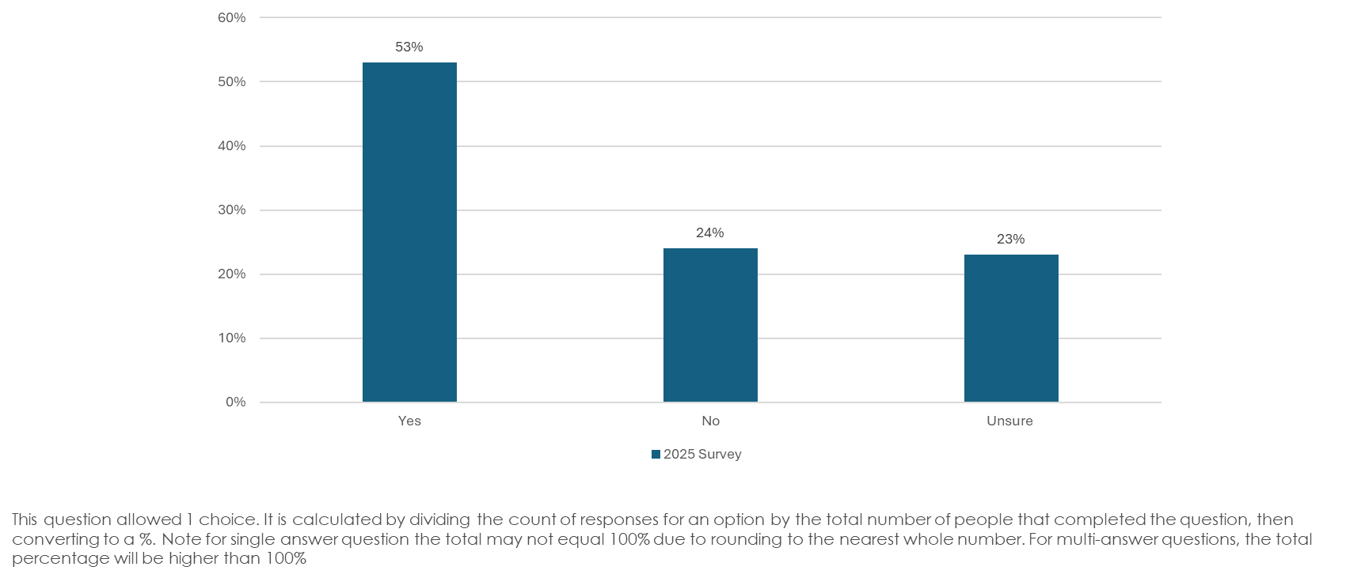

- Leadership and Governance: Participants express a need for councils to take stronger leadership in addressing climate change. Some comments highlight the lack of practical action and the prevalence of lip service, suggesting that councils should focus on tangible changes rather than theoretical plans. Others believe that councils should first address their own environmental impact before imposing changes on others. There is also a call for councils to work collaboratively with central government and local communities to promote sustainable solutions and raise awareness. Additionally, some participants feel that political and business influences hinder effective climate action.

- Financial Constraints and Rates: Participants expressed concerns about financial constraints impacting councils' ability to address climate change issues. Many feel that ratepayers cannot afford increased costs, and some believe funds are being wasted on ineffective projects. There is a call for councils to focus on essential services and reduce rates, rather than spending on climate initiatives. Some participants suggest that councils should prioritise projects with tangible community benefits and provide financial incentives for sustainable practices. Overall, there is a tension between the need for proactive climate action and the financial burden on ratepayers.

- Government Accountability: Participants express mixed views on government accountability regarding climate change. Some believe councils should adapt and innovate to address climate issues, aligning with international standards and focusing on impactful projects. Others argue that councils should focus on core services like water and roads, leaving climate action to other entities. Concerns are raised about ineffective actions, lack of leadership, and the need for councils to demonstrate their commitment through tangible actions and better resource management. Overall, there is a call for more transparency, consistency, and meaningful engagement in climate initiatives.

- Communication and Transparency: Participants expressed a need for better communication and transparency from councils regarding climate change efforts. Some noted the availability of information but suggested more public engagement and visibility of council activities, such as community events or information stands. Others highlighted the importance of councils providing up-to-date information to help individuals make informed decisions. There was also a call for councils to take a leadership role in raising awareness and promoting sustainable practices, while acknowledging the challenges of limited resources and political constraints.

- Infrastructure and Flood Protection: Participants emphasised the need for improved infrastructure and flood protection to address climate change impacts. Suggestions included restoring wetlands and bush areas, managing waterways, and enhancing flood banks. Some comments highlighted the importance of using renewable energy sources for critical services and incentivising regenerative farming practices. There was also a call for better urban planning, such as rewilding and creating rain gardens, to manage stormwater effectively. Additionally, participants mentioned the need for local councils to consider long-term strategies, like managed retreat and redesigning infrastructure to minimise flood risks.

- Farming and Land Use: Participants express a need for more proactive measures in farming and land use to address climate change. They suggest restoring wetlands and bush areas, managing waterways better, and acknowledging flooding risks. Some comments highlight the importance of aligning local efforts with international climate goals and standards. There is a call for stronger incentives for farmers to adopt regenerative practices and for councils to consider reforestation and sustainable infrastructure. Additionally, participants stress the need for integrated climate work within existing land and river management frameworks, rather than isolated efforts.

- Prioritisation: Participants expressed that councils should prioritise core services like water, roads, and flood protection over climate change initiatives. Some believe councils should focus on tangible projects with financial benefits, rather than 'feel-good' climate actions. Others suggest councils should support local resilience through community projects like food production and native planting. A few participants feel that councils should address climate adaptation rather than mitigation, focusing on local and regional needs.

- Community Engagement: Participants believe that councils, including Environment Southland, should enhance community engagement to address climate change. Some suggest a coordinated regional approach involving key industry and community stakeholders. Others highlight the need for councils to focus on urban areas and the entire community, not just farming. There is a call for tangible actions at the community level, such as local food production and native plantings, to increase resilience and reduce emissions. Participants also stress the importance of councils raising awareness and promoting sustainable solutions, while collaborating with organisations actively working on climate issues.

- Central Government: Participants expressed that central government should take a leading role in addressing climate change, as councils often lack the necessary support and resources. Many comments highlighted the need for a unified approach, aligning with international standards and ensuring consistent policies across regions. Concerns were raised about the central government's withdrawal of financial and regulatory support, which hampers local efforts. Additionally, participants noted the slow pace of government action and the need for stable, long-term policies that do not change with each election cycle.

- Climate Belief: A relatively small number of participants expressed scepticism about climate change, with some viewing it as a natural process or a hoax designed to generate revenue. They argued that efforts to combat climate change are futile, as changes are inevitable regardless of human intervention. Some comments suggested that councils should focus on practical environmental management, such as clearing waterways and controlling invasive species, rather than addressing climate change. Others mentioned that historical weather events have always occurred, questioning the current focus on climate change. A few participants highlighted the need to consider the broader impacts and potential benefits of climate change, such as warmer climates aiding agriculture.

- Emergency Preparedness: Participants expressed concerns about emergency preparedness in response to climate change. They highlighted the need for improved infrastructure, such as backup power sources for critical services and better communication systems. Suggestions included creating emergency-ready centres and developing local initiatives like communal food growing to enhance self-reliance. Some noted the unpredictability of climate events and the financial challenges councils face in proactive planning. Overall, there was a call for more tangible actions at the community level to enhance resilience and preparedness for future climate-related emergencies.

What would encourage you to take more action to reduce your impact on the changing climate and/or to prepare for its effects?

There were 71 comments provided. These can be grouped into the following common themes and topics.

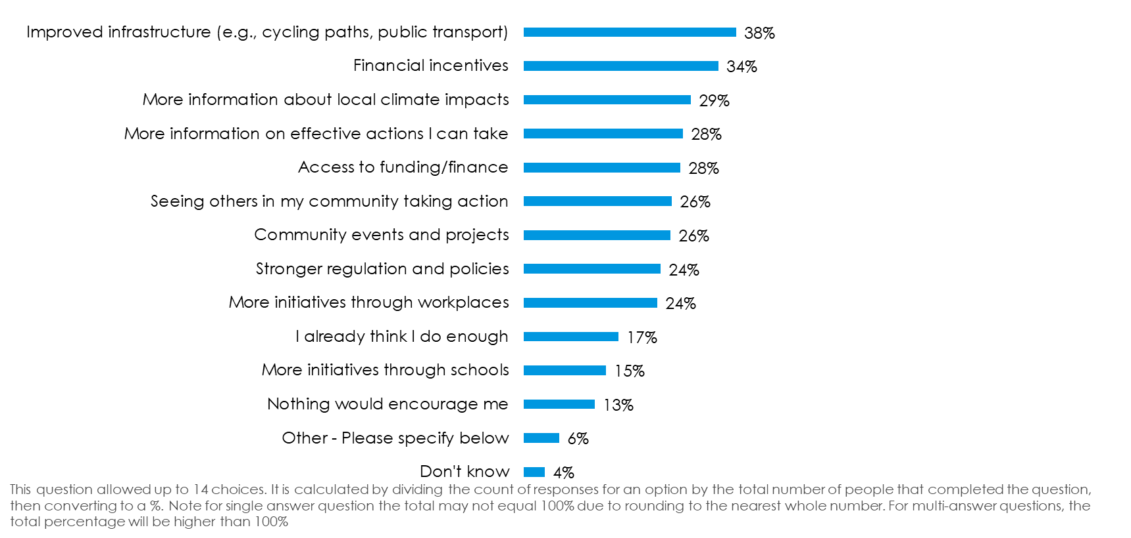

- Government Accountability: Participants expressed a desire for greater government accountability and leadership in addressing climate change. Many believe that visible actions by the government and corporations would encourage individuals to take more personal action. There is a call for smarter councils and governments to implement practical solutions, such as flood protection and water conservation, rather than spending on ineffective strategies. Some participants also highlighted the need for systemic changes, like improving emissions trading systems and ensuring industries contribute fairly to emissions reduction efforts.

- Transport: Participants expressed a desire for improved transport infrastructure to encourage climate-friendly actions. Suggestions included enhancing cycle paths and maintaining them to prevent punctures, which would make cycling more appealing. The introduction of electric trams and on-demand electric car services was proposed to reduce vehicle dependency. Additionally, there was support for reintroducing passenger rail services to improve public transport accessibility. Some participants highlighted the need for government investment in national public transport systems and incentives for rural areas to adopt electric bikes due to the lack of public transport options.

- Information and Evidence: Participants expressed a need for more accurate and science-based information about climate change and its effects. Some emphasised the importance of understanding the actual impact of individual actions on climate change. Others called for clarity on whether proposed changes would genuinely make a difference. There is a desire for less sensationalism and more factual evidence to guide actions. Additionally, some participants highlighted the need for localised information to better prepare for climate-related risks.

- Regulation: Participants expressed a need for sensible and balanced regulation to address climate change. Some highlighted the importance of working collaboratively with farmers to improve practices without unfair media criticism. Others criticised over-regulation, suggesting it can be counterproductive, as seen in the case of coal imports increasing emissions. There is a call for regulation to reduce plastic use, as current recycling efforts are insufficient. Additionally, some participants believe that local councils should encourage proactive community actions, and there should be fair and useful implementation of policies.

- Corporate Responsibility: Participants emphasised the need for corporate and governmental responsibility in addressing climate change. Many believe that genuine steps by corporations and governments would inspire individuals to take more action. There is a call for businesses to lead by example, as they are significant contributors to environmental issues. Participants also highlighted the importance of a cohesive approach across sectors, with some sectors currently resisting necessary changes like phasing out fossil fuels. Additionally, there is a desire for systemic changes, such as improved recycling practices and incentives for using sustainable materials, to make it easier for individuals to contribute to climate action.

- Financial Incentives: Participants expressed that financial incentives would encourage them to take more action to reduce their climate impact. Some suggested that government subsidies or incentives for solar panel installation would be beneficial. Others mentioned interest-free loans for energy-efficient home improvements, such as insulation and solar power, as helpful. Additionally, extending these financial supports to include water storage and drainage improvements was recommended. Overall, financial assistance is seen as a key motivator for individuals to invest in sustainable practices.

- Leadership: Participants emphasised the need for strong leadership from politicians and central government to address climate change effectively. They suggested that leaders should implement policies that encourage recycling and reduce reliance on fossil fuels. Additionally, there is a call for manufacturers to be held accountable for using non-recyclable materials. Participants also highlighted the importance of making sustainable practices, like using public transport and recycling, more accessible to the public.

- Environment and weather: Participants expressed a desire for improved weather conditions, such as longer spells of fine weather and less wind, to encourage climate action. The lack of infrastructure, like cycle paths, and the behaviour of drivers were noted as barriers to using active transport. Some participants highlighted the need for visible positive projects, such as revegetating land and creating pollinator pathways, to inspire community involvement. Additionally, there was a call for local authorities to take realistic actions concerning land use damage to protect the environment.

- Survey Feedback: Some participants expressed scepticism about the impact of climate change and the effectiveness of surveys on the topic. Some believe that climate change is exaggerated and that the focus on it negatively affects financial stability and cost of living. Others feel that the survey questions are ineffective and that the responsibility for pollution lies more with large organisations and government actions rather than individuals. There is also a sentiment that resources could be better utilised elsewhere.

- Sustainability: Participants highlighted several ways to encourage sustainable practices. One suggestion was for workplaces and businesses to take more responsibility, such as providing recycling bins and leading sustainability efforts. Another participant emphasised the importance of reducing packaging, particularly in fast food, and increasing recycling options for plastics and green waste. Additionally, the regulation of single-use plastics and promoting locally grown produce were mentioned as necessary steps. Lastly, encouraging water conservation through rainwater tanks was suggested as a practical measure for local councils to implement.

- Climate Belief: A relatively small number of participants expressed scepticism about human-caused climate change, questioning the reliability of climate models and the information presented. Some believe climate change is a natural process, while others call for more evidence and scientific debate. There is a sentiment that current climate actions are ineffective or financially burdensome, with some viewing international agreements like the Paris Accord as fraudulent. Overall, there is a demand for more factual information and less fear-based messaging regarding climate change.

Which actions have you taken in the past 12 months to prepare for climate impacts?

There were 69 comments provided. These can be grouped into the following common themes and topics.

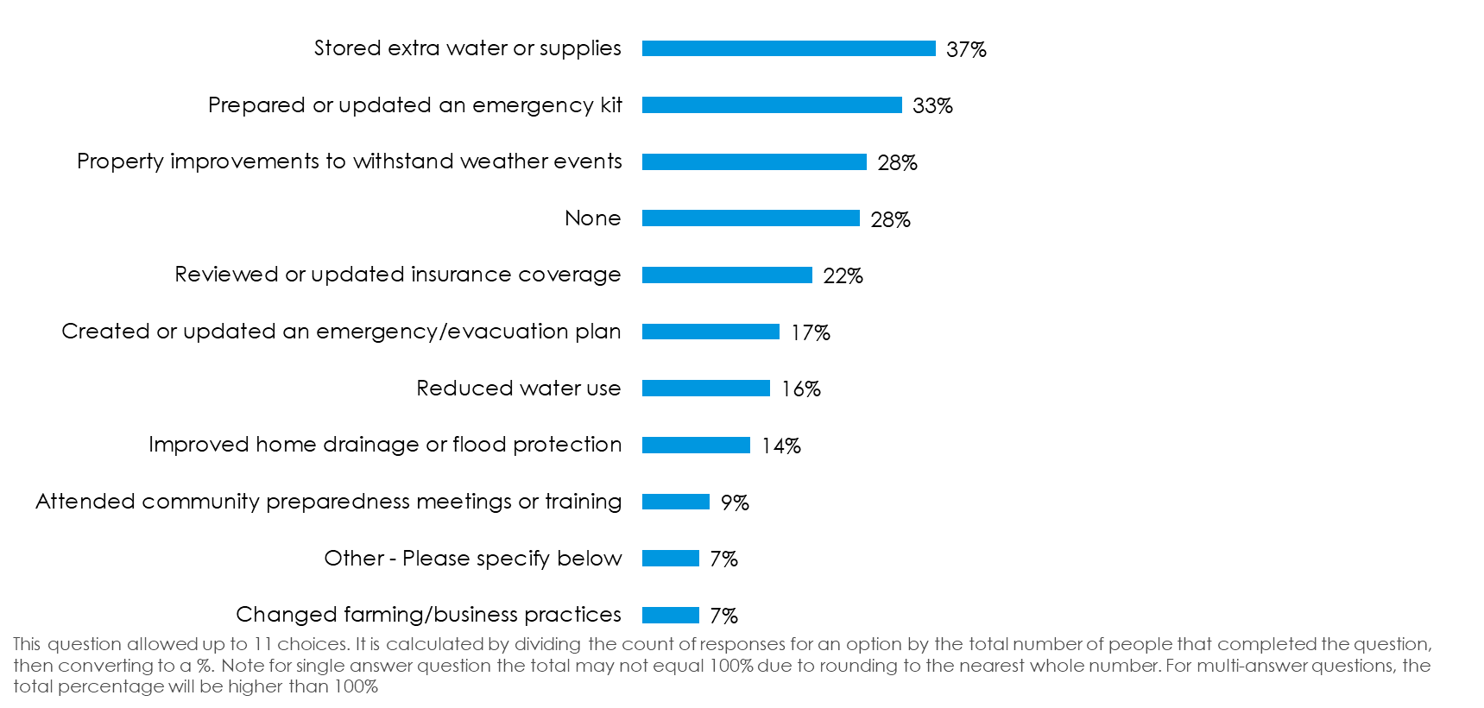

- Emergency Preparedness: Participants have taken various actions to prepare for climate impacts, focusing on emergency preparedness. Many have installed solar panels and batteries to ensure backup power and reduce reliance on the grid. Some have invested in emergency food supplies and water storage to be ready for natural disasters like tsunamis and earthquakes. Others have adopted off-grid living solutions, including generators and efficient log burners, to maintain essential services during power outages. Additionally, some participants have engaged in community preparedness workshops to enhance resilience and self-sufficiency.

- Energy Security and Power Resilience: Participants have taken various actions to enhance energy security and power resilience in response to climate impacts. Many have installed solar panels and battery systems to reduce reliance on the grid and ensure backup power during outages. Some have also invested in electric vehicles to lower carbon emissions and avoid fuel shortages. Others have opted for generators as a backup power source, while a few have embraced off-grid living, incorporating systems for power, water, and heating. Additionally, some participants have adapted their homes with efficient log burners and rainwater collection systems to prepare for extreme weather events.

- Self-Sufficiency and Food Security: Participants have taken various actions to enhance self-sufficiency and food security in preparation for climate impacts. Many have focused on growing their own food, with some changing the types of crops they cultivate to better suit changing conditions. Others have expanded their garden beds and planted fruit trees to increase self-reliance. Some participants are considering or have already started raising animals like chickens and pigs. Additionally, individuals are investing in off-grid living solutions, such as solar power and water storage, to ensure resilience during extreme weather events.

- Sustainability: Participants have taken various actions to prepare for climate impacts, focusing on sustainability and self-sufficiency. Many have installed solar panels and batteries to reduce carbon footprints and ensure backup power. Some have adopted electric vehicles to cut emissions and avoid fuel shortages. Others have engaged in gardening, planting trees, and increasing biodiversity to enhance resilience and self-reliance. Additionally, participants have prepared emergency supplies, such as food and water, and explored off-grid living options to maintain essential services during disruptions.

- Property Risk Avoidance: Participants have taken various actions to avoid property risks related to climate impacts. Some have chosen to purchase or build properties in areas less prone to natural hazards like flooding and sea level rise. Others have adapted their homes by incorporating features such as increased water storage, solar power, and raised foundations to mitigate flooding risks. Additionally, participants have engaged in activities like planting resilient trees and improving biodiversity to enhance property resilience. Selling properties in vulnerable areas and checking hazard risks before purchasing new properties were also mentioned as strategies to avoid climate-related property risks.

- Community and Institutional Gaps: Participants highlighted several community and institutional gaps in preparing for climate impacts. One participant noted the absence of preparedness meetings or training, suggesting a need for more organised community efforts. Another mentioned the lack of emergency or civil defence services in their area, indicating a gap in institutional support. Concerns were also raised about the lack of attention given to rural areas compared to urban ones, with some feeling their voices are not heard by representatives. Additionally, there was a call for better management of waterways to prevent flooding, suggesting that current practices are insufficient.

- Climate Belief: A relatively small number of participants expressed scepticism about the link between their preparedness actions and climate impacts. Some believe that preparing for natural disasters is a routine part of life and not specifically related to climate change. Others argue that climate impacts are not new and that humans have always adapted to changing conditions. There is also criticism of the notion that changing farming practices can mitigate climate impacts, with some viewing this as misinformation. Overall, the comments reflect a belief that climate change is a natural occurrence and not a cause for alarm.

- Farming Adaptation: Participants have taken various actions to adapt their farming practices in response to climate impacts. Some have focused on environmental measures, such as fencing waterways and planting native trees, to enhance resilience. Others have adapted their business operations by reviewing and modifying practices to better align with seasonal variations. Additionally, investments in infrastructure, like generators for power supply, have been made to ensure continuity in operations. Overall, these efforts reflect a proactive approach to managing climate-related challenges in farming.

- Water Management: Participants have taken various actions to manage water resources in preparation for climate impacts. Many have installed rainwater collection systems to ensure a reliable water supply. Some have adapted their homes by increasing water storage capacity and considering flood risks. Off-grid living is another approach, with participants ensuring they have independent systems for power, water, and sewage. Community efforts include workshops focused on water storage and resilience planning.

- Awareness: Participants have taken various actions to increase their awareness of climate impacts over the past year. Some have focused on educating themselves about natural hazards and their potential effects on their homes. Others have engaged in learning new skills, such as construction and maintenance, which could be beneficial if climate change affects local areas or supply chains. Additionally, individuals have been reading about climate impacts and considering these in their investment decisions. Efforts also include planting trees to store carbon and learning about adaptive gardening and food production methods. Overall, there is a strong emphasis on self-education and preparation for future climate challenges.

- Land, Biodiversity and Environmental Adaption: Participants have taken various actions to adapt to climate impacts, focusing on land, biodiversity, and environmental adaptation. Many have engaged in tree planting to enhance carbon storage and resilience against flooding. Efforts to protect and restore biodiversity include creating corridors and planting pollinator-friendly plants. Some have adapted their living conditions by building homes with considerations for flooding and drought, such as raising house levels and installing extra water tanks. Others have focused on fencing waterways and planting native trees to protect natural resources. Additionally, there are efforts to increase self-sufficiency through solar power and water storage, preparing for potential isolation due to extreme weather events.

What changes in the climate have you noticed in Murihiku Southland?

There were 90 comments provided. These can be grouped into the following common themes and topics.

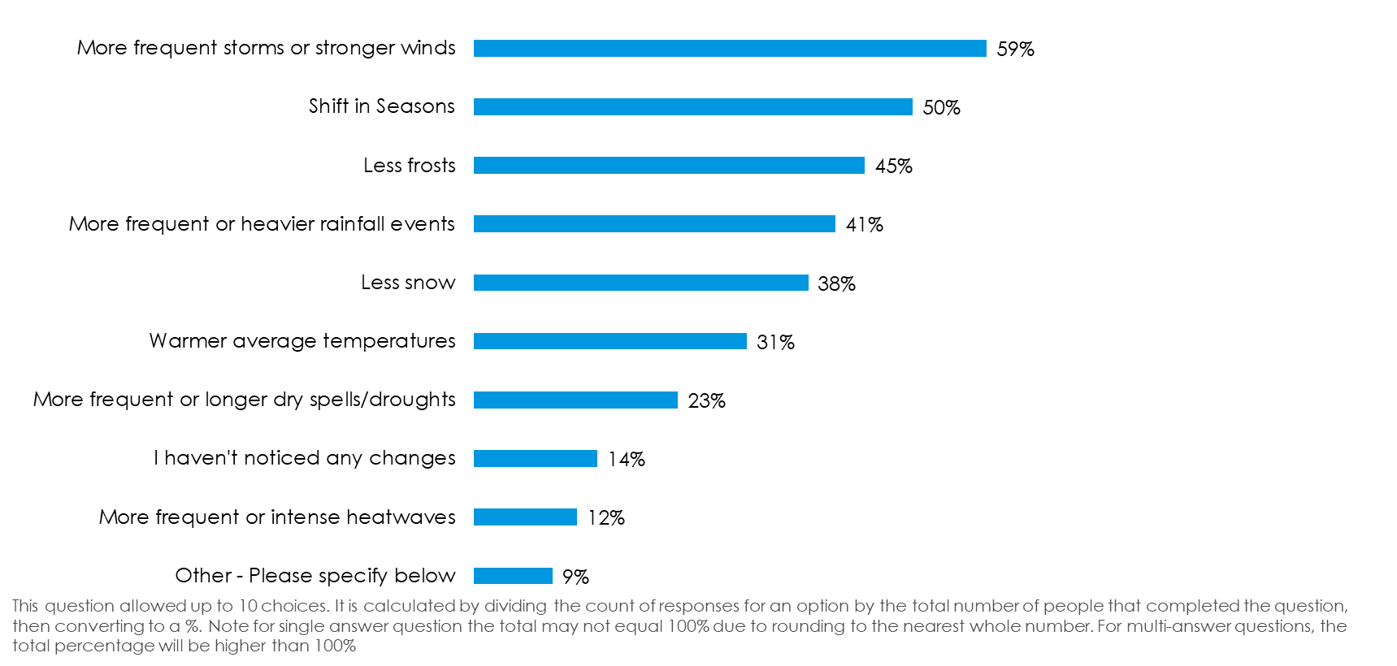

- Temperature, Frost and Snow: Participants in Murihiku Southland have observed notable changes in temperature, frost, and snow patterns. Many noted that winters are not as cold as they used to be, with milder temperatures becoming more common. There are fewer frosts, and snowstorms are less frequent, though when they occur, they can be more intense. Some participants mentioned that the region experiences more temperature fluctuations throughout the day, with stronger winds and unpredictable weather patterns. Additionally, the warming soil temperatures are leading to earlier spring growth, making plants more vulnerable to late winter cold snaps.

- Storm and Wind Events: Participants in Murihiku have observed an increase in storm and wind events. Many noted stronger and more frequent winds, with some mentioning specific unprecedented wind events affecting both rural and urban areas. There is also a perception of more easterly and northerly winds, deviating from the usual southerly patterns. While some participants find it challenging to attribute these changes directly to climate change, they acknowledge the noticeable shifts in weather patterns, including fluctuating temperatures and unpredictable seasons.

- Rainfall and Flooding: Participants have observed significant changes in rainfall and flooding patterns. Many noted an increase in major flood days, particularly in rivers like the Waiau, where flood gates remain open longer, leading to erosion of farmland. Heavier rainfall has been reported, causing issues with drainage and services. Some participants mentioned that rivers flood more quickly after rainfall due to gravel accumulation, requiring minimal rain to trigger flooding. Additionally, there is concern about higher water levels in rivers like the Ōreti and Waihōpai, with more frequent flooding events over the past decade.

- Biodiversity: Participants in Murihiku Southland have observed significant changes in biodiversity due to climate shifts. Many have noted the appearance of invasive species and fish typically found in warmer waters, indicating changes in ocean temperatures. There is also concern about the decline of native species, such as the Yellow-Eyed Penguins, due to these pressures. Additionally, shifts in plant growth cycles have been reported, with some plants flowering out of their usual seasons, affecting their interaction with pollinators. The increase in pest species and changes in insect populations further highlight the impact on local ecosystems.

- Unpredictability, Intensity and Variability: Participants in Murihiku Southland have observed increased unpredictability and intensity in weather patterns. Many noted that temperatures fluctuate more throughout the day, with stronger winds and quicker, more volatile weather changes. Some mentioned that springs start later and are colder and wetter than winters. There is a perception of greater extremes in weather, with some events becoming more intense. While some participants find it challenging to attribute specific changes to climate change without long-term data, they acknowledge the variability and unpredictability of the current climate.

- No Noticeable Change: Several participants from Murihiku Southland have not noticed any significant changes in the climate over the years. Some, like those who have lived in the area for decades, mention that the climate remains consistent, with typical variations such as floods, droughts, and temperature shifts being part of normal cycles. Others feel that the weather might be less harsh, but still within expected parameters. A few participants noted that they have not lived in the region long enough to observe any long-term climate changes.

- Coastal and Marine: Participants have observed several changes in the coastal and marine environment of Murihiku Southland. There is a noticeable increase in invasive species and fish typically found in warmer waters, indicating rising ocean temperatures. This shift has affected local marine life, including the decline of Yellow-Eyed Penguins due to climate pressures. Additionally, marine heatwaves are becoming more frequent and intense, impacting the ecosystem. Sea level rise is also a concern, affecting taonga species and access to mahinga kai resources.

- Shift in Seasons: Participants in Southland have observed notable shifts in seasonal patterns. Some have reported snow falling as late as November, indicating a delay in seasonal transitions. Winters and springs are described as wetter, with springs starting later and being colder and wetter than usual. Additionally, there is a mention of a very windy spring. While some note that winters are not as cold, others have experienced intense heat on the few hot days during spring and summer. These changes suggest a more unpredictable and intense climate pattern in the region.

- Climate Belief: A relatively small number of participants discussing climate belief in Murihiku Southland largely express scepticism about climate change, viewing it as a natural and historical phenomenon. Many comments suggest that climate has always changed over time and will continue to do so, with some participants dismissing the idea of human influence or intervention. A few comments mention that climate change narratives are exaggerated or used for fear-mongering. Overall, the sentiment reflects a belief in natural climate cycles rather than human-induced changes.

Do you have any other comments or feedback for local government agencies to improve its work programmes for responding to the changing climate?

There were 247 comments provided. These can be grouped into the following common themes and topics.

- Government Accountability: Participants expressed concerns about government accountability, particularly regarding financial management and decision-making in climate response programs. Many comments highlighted the perceived inefficiency and wastefulness of local councils, suggesting that funds are often misallocated or spent on unnecessary bureaucracy. Some participants called for a reduction in staff and a focus on core responsibilities like infrastructure, rather than climate change initiatives. Others emphasised the need for genuine community engagement and transparency, urging councils to listen to local voices and avoid being influenced by corporate interests or political agendas.

- Education and Engagement: Participants emphasised the importance of education and engagement in addressing climate change. Many suggested increasing educational efforts through schools and local media to raise awareness and prepare communities. There was a call for empowering communities with information and resources to enable them to find their own solutions. Participants also highlighted the need for collaboration with community groups and indigenous voices to personalise and enhance the educational message. Additionally, some comments suggested making climate action accessible and actionable for individuals, ensuring that everyone can participate effectively.

- Climate Belief: A relatively small number of participants expressed scepticism about climate change, viewing it as a natural cycle rather than a human-driven phenomenon. Some believe that efforts to combat climate change are futile and a waste of resources, suggesting that New Zealand's impact is negligible compared to larger polluting nations. Others argue that the focus should be on adapting to changes rather than attempting to alter the climate. There is a call for practical solutions, such as improving infrastructure and ensuring communities are prepared for severe weather events, rather than investing in climate change initiatives perceived as ineffective.

- Action and Implementation: Participants emphasised the need for Local Government agencies to take more decisive action on climate change, suggesting that visible projects and practical solutions should be prioritised. Many comments highlighted the importance of making data accessible to the public and ensuring actions are achievable for individuals. There was a call for less reliance on consultants and more direct implementation of solutions. Some participants stressed the urgency of addressing climate change to avoid higher future costs and losses, urging the agencies to act boldly and supportively, particularly in engaging with communities and farmers.

- Land Use and Environmental Stewardship: Participants emphasised the importance of planting native trees and protecting existing forests to enhance environmental resilience. Suggestions included fencing off waterways and increasing indigenous planting to improve carbon sinks and biodiversity. There was a call for more local powers to address businesses that neglect environmental impacts and for installing water quality monitors to identify pollution sources. Some participants advocated for strategic planning to address climate risks, such as avoiding development in flood-prone areas and implementing retreat plans for areas affected by sea-level rise.

- Rates and Affordability: Participants expressed concerns about the rising rates and affordability issues related to Local Government's climate response programmes. Many feel that the increasing rates are not justified by the returns, with some suggesting that funds are being wasted on unnecessary bureaucracy. There is a call for more efficient spending and prioritisation of essential infrastructure over costly climate initiatives. Some participants believe that the organisation should focus on visible, beneficial projects for ratepayers, such as incentives for home composting and rainwater storage, rather than increasing rates for climate-related activities.

- Strategy and Planning: Participants emphasised the need for a holistic approach in strategic planning, considering multiple dimensions of climate change simultaneously. Collaboration with experienced groups and long-term thinking are crucial for effective planning. Integrating climate strategies with regional management plans for water, coast, and land is essential to avoid misalignment and missed opportunities. Participants also highlighted the importance of making climate actions accessible and actionable for everyone, addressing barriers to individual participation. Additionally, incorporating climate risk into all planning and using cost-benefit analyses can help communicate the benefits to the community.

- Central Government: Participants expressed concerns about the central government's recent proposal to remove regional councillors, fearing it could disrupt coordinated climate responses. Some believe central government is influenced by corporate lobbying and advocate for grassroots movements to drive change. Others argue that central government is adequately addressing climate issues and that local councils should not duplicate efforts, which they see as bureaucratic and unnecessary. There is also a call for more direct government funding and for agencies to focus on infrastructure and core responsibilities, leaving broader issues to national governance.

- Science and Research: Participants emphasised the importance of basing climate response strategies on scientific facts and historical data. They suggested focusing on local research and avoiding over-reliance on computer models, which can be manipulated. There is a call for identifying areas vulnerable to sea level rise and flooding, and implementing retreat plans to prevent development in these regions. Additionally, participants highlighted the need for continuous monitoring and reporting of environmental changes, such as erosion and river conditions, to inform decision-making. Some expressed concern over government actions that might undermine environmental protection efforts.

- Sustainability: Participants provided various suggestions for improving sustainability efforts in response to climate change. Some emphasised the importance of promoting renewable energy and integrating sustainable practices into all government activities. Others suggested community initiatives like supporting home gardening and composting, and educating the public, especially in schools, about environmental impacts. There was also a call for innovative solutions such as vertical farming and replanting forests to enhance self-reliance. Overall, participants highlighted the need for a collective shift in attitude towards sustainability, with government agencies playing a key role in facilitating this change.

- Flood Protection and Rivers: Participants provided several suggestions for improving flood protection and river management in response to climate change. One recommendation is to invest in reforestation with native plants and restore natural river meanders to manage flooding better. Another suggestion is to focus on maintaining real infrastructure, such as flood banks, instead of relying heavily on modelled reports. Concerns were also raised about nitrate levels in rivers and the impact of increased dairy farming on water resources. Additionally, there is a call for more surveillance and responsiveness to complaints about river damage.

