|  |  |
| --- | --- |
|  | **Recommendation and decision on notification of resource consent application(s) under sections 95-95G of the Resource Management Act 1991 (RMA)** |

## Notification

Under s95A (2) (a) the application ***must*** be publicly notified as requested by the applicant.

*As the applicant has requested the application be publicly notified, no determination is required to be made as to the significance of adverse effects of the proposed activities. However, I consider the effects of the proposed activities will be, or may be likely to be, more than minor. I also consider that the cultural effects will be, or may be likely to be, more than minor.*

## The application

|  |  |
| --- | --- |
| Applicant: | Kanadale Limited |
| Application reference: | APP-20222376 |
| New consent(s) for new activity(ies) (s88) |  |
| New consent(s) for existing activity(ies) (s88) |  |

Kanadale Limited (the applicant) currently own a 352 ha dairy farm located east of Mataura Township. The applicant recently purchased two blocks of land known as the Murray Block (58.2ha) and the Bastaansian Block (50.2ha). Neither block has been utilised as a dairy farm in the past. The applicant proposes to incorporate these two blocks into their existing dairy platform and increase their dairy milking herd by 55 cows.

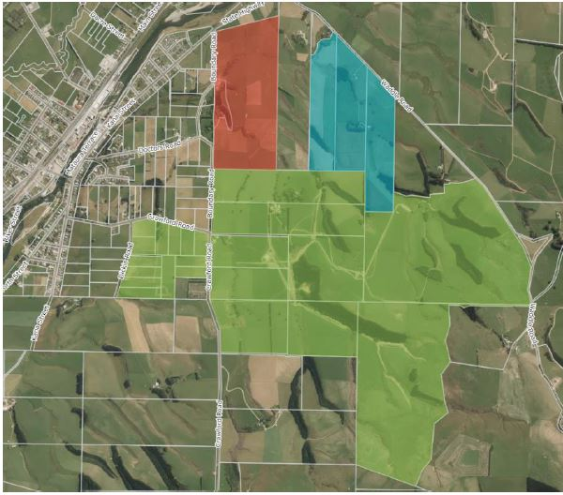

***Figure 1:*** *Farm map showing the two blocks of land (Bastaansion block in red and Murray block in blue) proposed to be added to the dairy platform.*

**Existing consents:**

* Discharge permit AUTH-302684-V1 that authorises the discharge of dairy shed effluent to land from milking up to 745 cows via low rate pods onto 172ha. The permit expires on 27 November 2028.
* Water permit AUTH-302685-V2 that authorises the abstraction of 89,400 L/day of groundwater for a dairy operation. The permit expires on 27 November 2028.
* Land Use Consent AUTH-302687 that authorises the conversion of land to a dairy farm. The permit was granted in perpetuity.

**Sought Consents:**

The application (APP-20222376) is for the following resource consents to authorise proposed activities at 135 Boundary Road, Mataura:

* **Discharge permit** to discharge dairy shed effluent to land from milking up to 800 cows from 1 August to 31 May (inclusive) via low rate pods, slurry tanker or umbilical system onto 191ha;
* **Water permit** to take 130.9m3 per day of groundwater from bores F46/0965 and CF12/5003 at a rate of 2L/sec;
* **Land use consent** to use land for two existing calving pads with 500mm wood chip base;
* **Land use consent** to expand a dairy farm by 108.7ha and increase the peak milking herd by 55 cows; and
* **Land use consent** for intensive winter grazing cattle on 37ha of crop on slopes over 10 degrees.

Overall, the application is a **discretionary activity**.

## Effects and Issues

The application is for several activities. Associated with these activities there are a number of issues. These include:

* the adverse effects on groundwater quality with specific regard to the levels of nitrogen;
* the adverse effects on surface water quality, in particular the Mataura River, with specific regard to the levels of nitrogen, phosphorus, sediment and microbial contaminants;
* the adverse effects of the activities on the Mauri of the water and the adverse cultural effects;
* adverse effects on soil structure and erosion; and
* cumulative effects on water quality, particularly in the lower catchment.

The Assessment of Environmental Effects is supported by a Riparian Management Plan, Farm Environmental Management Plan and OverseerFM nutrient modelling.

The applicant has requested full public notification, and from my review of the application and assessment of environmental effects, I consider that some of the effects listed above will have, or are likely to have “*more than minor”* effects.

## Public notification

Under s95A (2) (a) the application ***must*** be publicly notified as requested by the applicant.

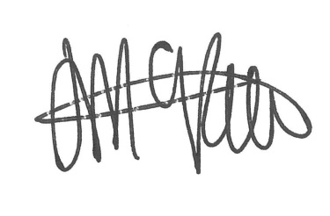

Jade McRae

**Senior Consents Officer**

**Date: 3 /10/2022**

# Delegated Authority Sign Off

|  |  |  |
| --- | --- | --- |
|  | **The application will be publicly notified** |  |

This decision is made under delegated authority by:

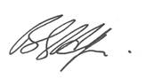

Bruce Halligan

**Consents Manager**

**Date:** 3/10/2022