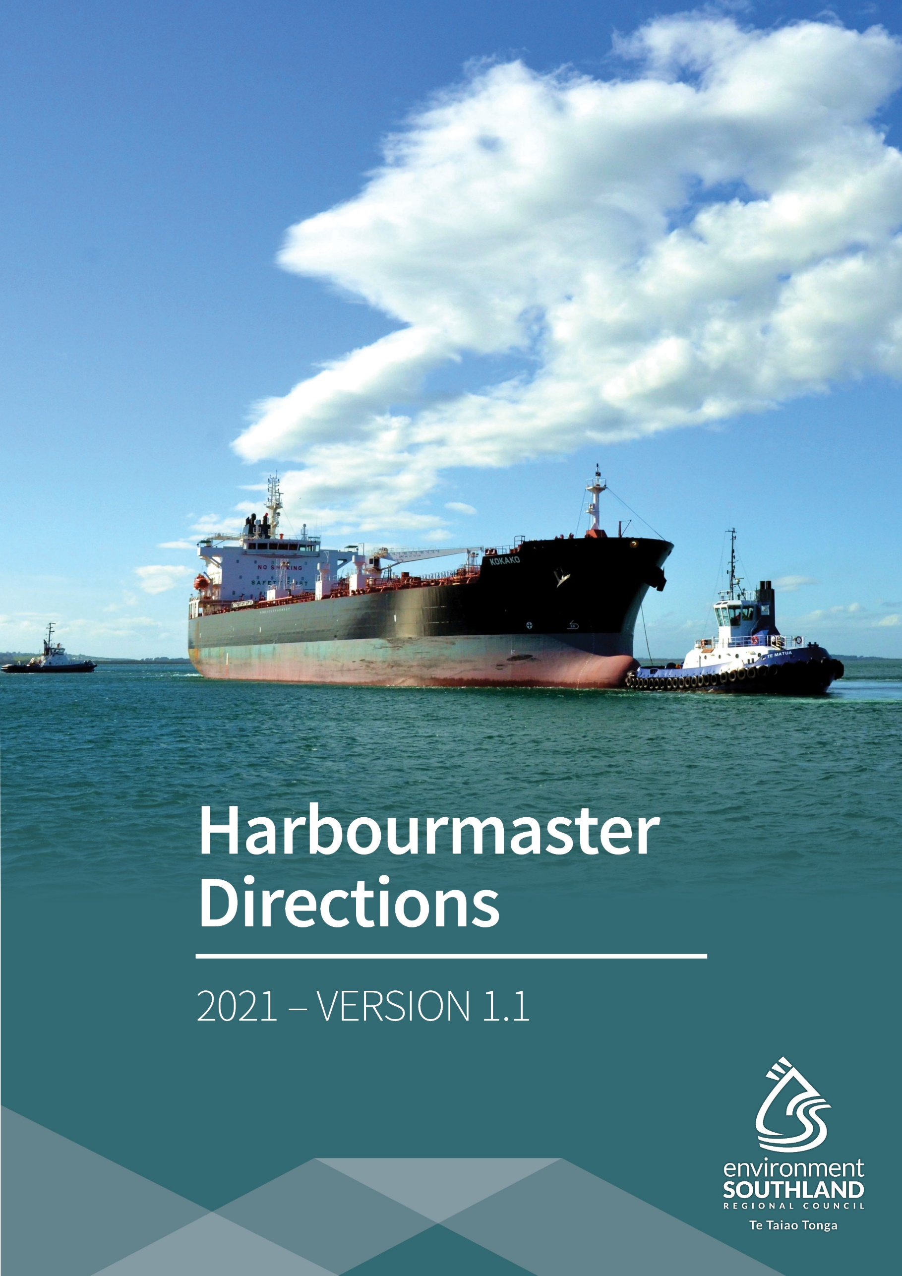

Table of Contents
Foreword 4
Preamble 4
1. Interpretation 5
2. Application 6
3. Variation 6
4. Liability 6
5. Parts 7
5.1 Hazardous activities (hot work, dangerous goods, transfer of oil) 7
5.2 Seaworthiness, vessel defects, use of and immobilisation of engine, fuel changeover 7
5.3 Vessel operating requirements and limitations 7
5.4 Pilotage intro to 6.4 7
5.5 Miscellaneous provisions (port closure, quarantine anchorage) 8
5.6 Revocation of previous Harbourmaster’s Directions 8
6.1 Hazardous activities (hot work, dangerous goods, transfer of oil) 9
6.2 Seaworthiness, vessel defects, use of and immobilisation of engine 11
6.3 Vessel operating requirements and limitations 13
6.4 Pilotage 15
6.5 Miscellaneous provisions (quarantine anchorage, port closure) 17
6.7 Revocation of, and amendments to, previous Harbourmaster’s Directions 17
Appendices 18
Appendix 1 – Southland Region 18
Appendix 2 – Milford Sound Pilotage Area 19
Appendix 3 – Thompson/Doubtful Sound Pilotage Area 20
Appendix 4 – Breaksea/Dusky Sound Pilotage Area 21
Appendix 5 – Stewart Island Pilotage Area 22

Foreword
Environment Southland has adopted the New Zealand Port and Harbour Marine Safety Code (the Code) and applies the principles described within the code to marine operations on the region’s waters.
The movement of vessels within the Southland region is subject to control and direction by the Harbourmaster. These directions set a number of control measures that are applicable across the region, or a specific area or operation, to enable the adequate implementation of the code.

Preamble

Pursuant to:

- Section 33F of the Maritime Transport Act 1994; and
- Section 48 and Section 60A(2) of the Maritime Transport Act 1994, as delegated by the director to the Harbourmaster under section 444(2) of the Act and consented by the Minister of Transport under Section 444(4) of the Act; and
- Maritime Rules; and
- the Bylaw;

for the purpose of mitigating risks to maritime safety by controlling the safe operation of vessels in the region’s waters, including, particularly, port areas and harbours, the Harbourmaster directs that vessel and related maritime activities shall be conducted in accordance with the applications, purposes and requirements of these Directions.

1. Interpretation

In these Directions, unless the context otherwise requires:

Act means the Maritime Transport Act 1994.

Automatic identification system (AIS)
means an operational transceiver of class A or class B that complies with the requirements of the International Maritime Organisation (IMO).

Bylaw means the Southland Regional Council Navigation Safety Bylaw 2009 (Revised 2015).

Southland Region
means the area under the control of the Southland Regional Council, the sea area of which is all the area between Waiparau Head in the Catlins to Awarua Point in Fiordland with an outer boundary being the seaward limit of the territorial sea and an inner boundary being the water’s edge and includes all estuaries, inlets or harbours and coastal waters.

Commercial port
means the same as defined in section 33B of the Act.
Explanatory note: For the sake of clarity, this includes Bluff, Riverton and Fiordland.

Council
means the Southland Regional Council (also known as Environment Southland).

Cruise ship
means any ship over 1000 gross tons (International Convention System), the main purpose of which is to carry passengers for hire.

DUKC calculation
means a method of calculating Dynamic Under Keel Clearance where this is implemented, such as the systems DUKC® used by LPC or DHI NCOS Online used by PPT.

Gross tonnage (GT)
means the gross tonnage of a ship determined under Maritime Rules Part 48 or the tonnage measurement rules contained in Annex 1 of the International Convention on Tonnage Measurements of Ships 1969, as the case may be.

Harbourmaster
means a person appointed as a Harbourmaster by the Southland Regional Council under Section 33D of the Act.

Large vessel
means a vessel that is:
- 500 GT or greater; or
- 40 metres length overall or greater.

Length overall (LOA)
means the same as defined in Maritime Rules Part 40A.

Pilot means a person holding a current Pilot Licence for the relevant pilotage area.

Pilotage area
means any area described in Maritime Rules Part 90, or a Harbourmaster’s direction, where a vessel is required to carry a Pilot.

Pilot Exempt Master (PEC Master)
means a Master holding a current Pilotage Exemption Certificate (PEC) for the Bluff, Stewart Island or Fiordland Pilotage areas issued under Maritime Rules Part 90.

Small vessel
means a vessel that is not a large vessel.

Vessel
means the same as “ship” as defined in Section 2 of the Act.
- To avoid doubt, compliance with this Direction does not remove the need to comply with all other applicable acts, regulations, bylaws, and rules of law.
- Unless the context requires another meaning, a term or expression that is defined in the Act or a Maritime Rule or the Bylaw and used in this Direction, but not defined, has the meaning given by the Act or Maritime Rule or the Bylaw.

2. Application

These Directions contain several parts and, in terms of its area of concern and vessel types, applies, has a purpose, and particular requirements according to each part as stated within them.

3. Variation

The Harbourmaster may, upon written application, vary the rules in these Directions for a vessel or specific class of vessels. This will be done on a case-by-case basis, and only where the overall standards of maritime safety are, in the opinion of the Harbourmaster, maintained.

4. Liability

The Council shall not, in any case, be responsible for any loss or damage arising from the negligence of the Master or crew of any vessel to which these Directions apply, or for any loss, damage or incident involving the vessel.

5. Parts

5.1 Hazardous activities (hot work, dangerous goods, transfer of oil)

- Responsibility for approvals and notifications.
- Specific approval from the Harbourmaster required for hot work in certain circumstances.
- Notification and approval requirements for hot work not requiring specific approval from the Harbourmaster under clause 1).
- Revocation of approval or permission to conduct; direction to cease; right to inspect or audit hot work operations.
- Restrictions on vessels in proximity to hot work being undertaken ashore in certain circumstances.
- Requirement to obtain a Gas Free Certificate.
- Notification of arrival of vessels carrying Class 1 dangerous goods.
- Transfer of oil (between vessel and shore).

5.2 Seaworthiness, vessel defects, use of and immobilisation of engine, fuel changeover

- Movement of unseaworthy vessels.
- Inoperative equipment.
- Requirement to have Harbourmaster’s permission in cases where equipment is inoperative.
- Lost anchor, chain, cable, propeller, cargo or other material.
- Use of the vessel engine while alongside.
- Engine immobilisation.
- Fuel changeover.

5.3 Vessel operating requirements and limitations

- Notification of vessel movements to port company.
- Notification of shaft limitations
- Declaration of particulars of a vessel.
- Requirements for oversize vessels.

5.4 Pilotage

- Vessels to navigate in accordance with navigation safety operating requirements and procedures.
- Requirement to have an agreed Passage Plan.
- Leading in/out provisions and limits.
- Annual currency requirements for Pilots and Pilot Exempt Masters.

5.5 Miscellaneous provisions (port closure, quarantine anchorage)

- Location of quarantine anchorage.
- Closure of the port to a vessel movement shall be done in consultation with the Harbourmaster.

5.6 Revocation of previous Harbourmaster Directions

- Previous Harbourmaster Directions are revoked.

6.1 Hazardous activities (hot work, dangerous goods, transfer of oil)

Application:
Except where stated otherwise this part applies to all vessels in commercial port areas in the Southland Region.

Purpose:
To mitigate risks to maritime safety by requiring that hazardous activities be conducted in an appropriate manner and within relevant regulations (where these exist); and by requiring that relevant parties be made aware of hazardous activities being conducted so that possible conflicts between hazardous activities are avoided as far as that is practicable. This part is to be read in conjunction with Maritime Rules Part 24A and Marine Protection Rules Part 103 and Part 130B.

Requirements:

1. Responsibility for approvals and notifications
(a) Notwithstanding the responsibility of the vessel’s master for ensuring that applications for approval and notifications of hazardous activities are made, any of the following may seek approval or make notification as may be appropriate to the circumstances or agreed practice between the parties involved:
- the vessel’s master (or delegated crew member); or
- the company contracted to undertake the work or activity; or
- the vessel’s owner; or
- the vessel’s port agent; or
- the relevant port company.

2. Specific approval from the Harbourmaster required for hot work in certain circumstances
(a) Specific prior written approval from the Harbourmaster shall be obtained before any hot work may commence on board any vessel that is:
- carrying, loading, or discharging Class 1 Dangerous Goods as cargo or as part of the vessel’s operation (e.g. Tuna bombs);
- within the Explosives Exclusion Zone of any vessel that is carrying, loading, or discharging Class 1 Dangerous Goods as cargo or as part of the vessel’s operation;
- carrying, or that would ordinarily carry, liquid or gas hydrocarbons in bulk as cargo (i.e. any fuel/oil tanker, any gas carrier);
- intending to conduct hot work in or on any tank on the vessel (including connected pipework not isolated from the tank) or confined space on the vessel that contains or has previously contained bulk petroleum products, or drums of petroleum products;
- undertaking any transfer of oil between the vessel and shore:
(1) within the pilotage area of Bluff, Stewart Island or Fiordland that is not secured alongside a wharf, Jetty or other landing place;
(2) except where allowed by the Harbourmaster, the relevant Port Company, and the relevant oil terminal operator(s), alongside an oil terminal berth (i.e. Town Wharf in Bluff);
(b) Approval must be applied for during normal working hours (0800-1600) not less than one full working day prior to the hot work’s planned commencement.
(c) Approval must be applied for in a form and manner satisfactory to the Harbourmaster, as shown on the Council’s website at the time approval is sought.

3. Notification and approval requirements for hot work not requiring specific approval from the Harbourmaster under clause 2)
(a) Provided that:
- any permission required by the relevant Port Company has been granted but has not been revoked; and
- notification in a form and manner satisfactory to the Harbourmaster has been given; and
- the planned hot work will not be undertaken in any circumstance listed in clause 2);
approval for hot work shall be automatically granted according to the conditions on the Hot Work Notification form.
(b) Notification must be given in a form and manner satisfactory to the Harbourmaster, as shown on the Council’s website at the time of notification.
(c) Notification must be made not less than 3 hours but not more than 96 hours prior to the commencement of work.
(d) Except in any circumstance listed in clause 2, notification is not required to be made for hot work that is to be conducted on any small vessel at Stewart Island or in Fiordland.

4. Revocation of approval or permission to conduct; direction to cease; right to inspect or audit hot work operations
(a) The Harbourmaster may at any time revoke any approval given under clause 2 or 3.
(b) The Harbourmaster may at any time direct any hot work operation being undertaken on any vessel in the Southland Region to cease.
(c) The Harbourmaster may at any time direct any hot work operation being undertaken in a port area to cease.
(d) The Harbourmaster may at any time inspect or audit any hot work operation being undertaken on board any vessel or in any port area in the Southland Region.
(e) A port company staff member approved to do so by the port company may at any time revoke the port company’s permission to undertake hot work. Such revocation must be communicated to the Harbourmaster immediately it is undertaken.
(f) A port company staff member approved to do so by the port company may audit or inspect hot work approved by them or being conducted in their port area.
(g) Any revocation of approval or direction to cease conducting hot work shall apply immediately it is given and no hot work to which it applies shall be permitted under any other approval that may have been granted.

5. Restrictions on vessels in proximity to hot work being undertaken ashore in certain circumstances
(a) No vessel carrying, loading, or discharging Class 1 dangerous goods as cargo or as part of the vessel’s operation shall remain alongside whilst hot work is being conducted within the explosives exclusion area of that vessel.
(b) No vessel shall berth at or remain alongside a fuel terminal berth (i.e. Town Wharf in Bluff) whilst hot work is being undertaken on that berth.

6. Requirement to obtain a Gas Free Certificate
(a) The Master of any vessel shall ensure a Gas Free Certificate is obtained from an industrial or analytical chemist or other competent person before any repairs are carried out on or in a tank (including connected pipework not isolated from the tank) or confined space on the vessel that contains or has previously contained bulk petroleum products, or drums of petroleum products; or before any persons enter such a tank or confined space.
(b) If the repairs are to continue beyond midnight on any day then the Master of the vessel shall ensure a new daily Gas Free Certificate is obtained.
(c) The Master of the vessel shall ensure the Gas Free Certificate for the day is displayed at the gangway or other clearly visible appropriate place on the vessel.

7. Notification of arrival of vessels carrying Class 1 dangerous goods
(a) According to the requirements of Maritime Rules Part 24A, Rule 24A.86, notification of arrival of any vessel carrying Class 1 dangerous goods must be given to the Harbourmaster:
- if the vessel is on a domestic voyage, as soon as possible following departure from its previous port of call and in any case before the vessel enters the port; or
- if the vessel is on an international voyage, at least 48 hours before arrival at the port.

8. Transfer of oil (between vessel and shore)
(a) No transfer of oil between a vessel and the shore may be undertaken except:
- at an oil transfer site in accordance with the provisions of a site marine oil spill contingency plan approved under Marine Protection Rules Part 130B for that site; and
- when notification has been given according to the requirements of Marine Protection Rules Part 103.
(b) No transfer of oil between a vessel and the shore may be undertaken whilst hot work is being undertaken within 50 metres of the transfer connection point or breather outlet of the tank to or from which oil is being transferred.
(c) Notification required under 8(a)(i) must be given in a form and manner satisfactory to the Regional On-Scene Commander, as shown on the Council’s website at the time of notification.

6.2 Seaworthiness, vessel defects, use of and immobilisation of engine

Application:
Except where stated otherwise this part applies to large vessels in the sea area of the Southland Region.

Purpose:
To mitigate risks to maritime safety by limiting the movement of vessels that have reduced seaworthiness or defective equipment or that have lost something overboard; and limiting the use or immobilisation of engines in some areas; and requiring vessels to undertake certain activities, that may affect maritime safety, only at times or locations where any adverse effects may pose a lesser risk to maritime safety; and requiring vessels to seek the permission of or inform relevant parties of these events in some circumstances.

Requirements:

1. Movement of unseaworthy vessels
(a) If an incident involves damage to a large vessel that affects or is likely to affect its seaworthiness the Master shall not move the vessel except to clear the main navigational channel; or to moor or anchor in safety; or to act in accordance with the directions of the Harbourmaster.

2. Inoperative equipment
(a) All vessels navigating within the sea area of the Southland region must report to the Harbourmaster and the relevant port company:
- prior to entering the region’s waters or departure from any berth or anchorage within the region any deficiencies with or any inoperability of any of the vessel’s navigational or manoeuvring equipment;
- 24 hours in advance, or as soon as possible if the passage from the previous port is less than 24 hours duration, any deficiencies with or any inoperability of any of the vessel’s navigational or manoeuvring equipment where a vessel is to enter into or navigate within any pilotage area.

3. Requirement to have Harbourmaster’s Permission in cases where equipment is inoperative
(a) Any vessel with deficient or inoperative navigation or manoeuvring equipment may not enter into, or depart any wharf or anchorage within, a pilotage area without the prior permission of the Harbourmaster.
(b) In granting such permission the Harbourmaster may give a direction as to the manner in which such vessel navigates within the pilotage area. Such direction may include the requirement to use tugs, wind limits on operations, or any other such requirements as may be deemed necessary by the Harbourmaster.

4. Lost anchor, chain, cable, propeller, cargo or other material
(a) The Master of any large vessel that has parted from any anchor, chain, cable or propeller, or lost overboard any material or cargo that may endanger safety or navigation, shall:
- Broadcast on VHF Ch 16, advising other mariners; and
- leave a buoy to mark the position of a submerged anchor, chain, cable, propeller, other material or cargo if this is known; and
- immediately report the occurrence to the Harbourmaster and, if in a harbour area, harbour control; and
- give specific details of the loss to the Harbourmaster including the position of the anchor, chain, cable, propeller, other material or cargo; and
- if the Harbourmaster so directs, undertake the recovery of it as soon as practicable.

5. Use of the vessel engine while alongside
(a) No person shall operate the propulsion system of a large vessel while it is lying at any landing place without the permission of the relevant port company.
(b) In addition to the requirements of subclause 5(a), the Master of the vessel shall ensure all persons at the landing place and on vessels in the immediate vicinity of that vessel and Harbour Control are warned immediately prior to the propulsion system being tested.
(c) Subclause 5(a) shall not preclude the use of the propulsion system for the:
- safe movement of a vessel to or from a landing place; or
- ordinary pre-departure testing in a manner that does not cause disturbance to other vessels in the port.

6. Engine immobilisation
(a) A vessel may only immobilise its main engine when:
- securely moored at a landing place; and
- the Master has ensured that the permission of the facility owner has been obtained.
(b) No Tanker or Bulk Oil Carrier may immobilise its main engine or manoeuvring equipment when at anchor or underway without the permission of the Harbourmaster.
(c) The Harbourmaster is to be informed of all other port company approved engine immobilisation requests.

7. Fuel changeover
(a) Any vessel which is to change between fuel types used for its propulsion shall:
- if entering the Southland Region, have completed the fuel changeover and been running on the new fuel for at least 4 hours prior to entry into the region’s waters;
- if departing from the Southland Region, only undertake the fuel changeover after having departed from the region’s waters.

6.3 Vessel operating requirements and limitations

Application:
Except where stated otherwise this part applies to large vessels in pilotage areas of the Southland Region.

Purpose:
To ensure that vessels manoeuvring within a pilotage area can be navigated in a manner that will not adversely affect the safety of navigation, is within international standards or, where not, that there are adequate mitigating measures in place such as restricting cruise ship access to Fiordland at certain times.

Requirements:

1. Notification of vessel movements to port company
(a) The Master shall ensure that at least 24 hours prior notice is given to the relevant Port Company of the vessel’s arrival at:
- Bluff Harbour.
(b) The Master shall ensure that at least one hour’s prior notice is given to Harbour Radio of the vessel’s departure from, or movements within, the port of Bluff.
(c) The Master of any vessel not carrying a Pilot that is about to transit the Bluff Inner Harbour shall ensure a broadcast to all stations is made on VHF Channel 14 in sufficient time to alert other traffic as to the intended transit.

2. Notification of shaft limitations to pilot
One method being employed to improve Carbon Intensity Indicator ratings (reduce carbon intensity) is to improve fuel efficiency by means of Engine Power Limitation or Shaft Power Limitation systems onboard vessels. The use of these methods may inhibit the ability for vessels entering Bluff Harbour to be safely manoeuvred.
(a) The master of any vessel intending to manoeuvre within Bluff Harbour pilotage limits must provide to the pilot the RPM corresponding to the engine setting on the pilot card in a timely manner and without delay. Any system restricting such timely action of the engine must be disabled prior to taking a pilot.

3. Declaration of particulars of a vessel
(a) The Master of any large vessel arriving at Bluff Harbour shall supply to the port company all such pre-arrival details regarding the vessel according to the port company’s pre-arrival requirements.
(b) When requested, the Master of any large vessel arriving at any port in the Southland Region shall supply to the Harbourmaster in a form and manner satisfactory to the Harbourmaster a declaration that is to the best of the Master’s knowledge a correct statement of:
- the tonnages of the vessel; and
- the draft of the vessel; and
- the vessel’s last port of call and next destination; and
- the vessel’s ownership, Registry details and details of the company managing the operation of the vessel; and
- details of any explosives, dangerous goods, flammable liquids and oils carried as cargo; and
- any other information requested by the Harbourmaster that is needed for navigation safety purposes.

3. Requirements for oversize vessels
(a) No vessel in excess of the following sizes may navigate within pilotage limits without the prior permission of the Harbourmaster:
(i) for vessels visiting the Port of Bluff:
(1) maximum length overall 225 metres
(2) maximum beam 34 metres
(3) minimum under keel clearance 1.2 metres.
North Channel
- maximum length overall 70 metres
- draft of less than 5 metres
(b) Permission granted under 3(a) may be notified to the port operator or facility owner, as agent for the ship owner, in cases where the permission cannot be passed to the ship’s Master.
(c) In granting such permission the Harbourmaster may require a vessel to be computer simulated in order to set safe operating criteria.
(d) Simulated assessment exercises carried out at SmartShip Australia, are exempt from 3(a).
(e) Where a ship owner, master or agent is unable to provide a simulation for the vessel the Harbourmaster may refuse entry to, or set strict operating criteria in respect of, that vessel. Such criteria shall be set by the Harbourmaster after consultation with the facility owner and/or port operator.

4. Wind limits
(a) Every commercial port shall, in consultation with the Harbourmaster, set and operate agreed wind limit guidelines for that port.

5. Requirements and limitations for cruise ships and vessels operating in Fiordland Internal Waters
(a) No more than two cruise ships shall enter any waterway, passage, fiord, bay or inlet at the same time in any one day.
(b) No more than three cruise ships shall enter Fiordland internal pilotage waters in any one day.
(c) No cruise ship may enter the internal pilotage waters of Milford Sound or depart from any anchorage within these waters between the hours of nautical dusk and nautical dawn.
(d) The requirements to 5(c) shall not prevent the Harbourmaster or delegated officer (Harbourmaster staff member) allowing a specific vessel permission to navigate between the hours of nautical dusk and nautical dawn where the circumstances of the case are deemed not to compromise the overall safety of navigation.
(e) This may mean that in the early or late stages of the cruise season, where days are shorter, a vessel may be able to make arrangements to be allowed to enter the Internal Waters before the start of nautical dawn. This could only occur if the weather and the visibility conditions are sufficiently good (i.e. clear skies, calm winds and no fog, mist or rain).
(f) Vessels are required to have a minimum stand-off distance of 50 metres from the main waterfalls within the internal pilotage waters of Milford Sound.

6. Requirements and limitations for cruise ships operating in Stewart Island Internal Waters
(a) No more than two cruise ships shall enter any waterway, passage, fiord, bay or inlet in any one day.
(b) No more than two cruise ships may enter Stewart Island internal pilotage waters in any one day.
(c) Pilotage cap limits for cruise ships:
- 90,000 GT
- 300m LOA
- Wind cap <15 knots
- Sea state cap – 2m maximum on approaches

6.4 Pilotage

Application:
Except where stated otherwise this part applies to large vessels in pilotage areas of the Southland Region.

Purpose:
To control the manner in which vessels may be navigated in pilotage areas; and to prescribe the use of Pilot Licences and Pilotage Exemption Certificates within pilotage areas. This part is to be read in conjunction with Maritime Rules Part 90.

Requirements:

1. Vessels to navigate in accordance with navigation safety operating requirements and procedures
(a) All vessel Masters and Pilots navigating within a pilotage area (the limits of which are marked in green on the charts in Appendices and must operate within the criteria laid down in a Pilot or PEC Master standard operating procedures or guidelines approved by the Harbourmaster. This also includes the Environment Southland Cruise Ship Deed of Agreement between the Council and the New Zealand cruise ship industry.

2. Requirement to have an agreed Passage Plan
(a) A Pilot or PEC Master must prepare a passage plan for their intended passage within a pilotage area.
(b) For the Fiordland pilotage area, cruise ship masters must ensure that the approved Environment Southland Fiordland passage plans are used for reference. The vessels own passage plans must be reviewed against these and any necessary changes made well in advance of:
- entering Fiordland Pilotage Limit waters; and
- master/pilot exchange taking place.
Note: Approved passage plans can be found on the Environment Southland website under Maritime/Cruise Ships.
(c) A Master and a Pilot on a vessel shall exchange information pertinent to the navigation of the vessel in order to agree a passage plan. Such information exchanged shall include, but not be limited to:
- relevant information concerning the vessel’s manoeuvrability; and
- the vessel’s draft, dimensions and tonnages; and
- any non-operational, or constraints on the use of, equipment; and
- proposed berthing arrangements; and
- the proposed courses to be taken; and
- the use of tugs.
(d) Where the Master and a Pilot are unable to agree on a passage plan, the vessel shall proceed to the nearest safe anchorage and remain anchored until agreement has been reached.
(e) Where no agreement can be reached the Harbourmaster must be notified immediately.
(f) Any generic passage plans to be used by a Port Company shall be discussed with and approved by the Harbourmaster.

The approved Environment Southland Passage Plans can be downloaded here:
Fiordland Stewart Island Passage Plans

3. Leading in/out provisions and limits
(a) As per the requirements of Maritime Rules part 90, vessels requiring a Pilot must have a Pilot on board and in charge of the vessel within a pilotage area except in circumstances where it is not possible, because of the construction of the vessel, in the prevailing weather conditions to safely transfer the pilot at the appropriate pilot transfer site outside the Pilotage Limit. In such cases the vessel, provided the vessel’s Master is in agreement, may be led into or out of the harbour by a tug or pilot vessel, with a Pilot on board, until the Pilot considers it safe to board the vessel (in the case of leading in) or following the Pilot’s disembarkation from (in the case of leading out) the vessel subject to the following limitations:
(i) For inbound vessels:
(1) for Bluff Harbour, leading in shall be restricted to vessels under 50m;
(2) for Milford Sound, limited to safe waters adjacent to St Anne Point.
(ii) For outbound vessels, a Pilot must be carried until the vessel is in safe water and, unless weather or sea conditions are such that there is a high risk to the safety of the Pilot when disembarking:
- for Bluff Harbour, leading out shall be restricted to vessels under 50m
- for Milford Sound, pilot disembarkation limited to safe waters adjacent to St Anne Point.
(b) Safe waters being calmer conditions for boarding when a vessel is entering or on the No.1 leads with designated course outward bound.
(c) In circumstances where the Pilot is leading a vessel in or out, the vessel must be actively monitored by all available means including being within visual sight of the Pilot until it is in safe water or the Pilot has boarded.
(d) The Harbourmaster may require any vessel to be piloted by a Pilot within a pilotage area where, in the Harbourmaster’s opinion, circumstances are such as to place the safety of the vessel, other vessels, people, or property in jeopardy.

4. Annual currency requirements for Pilots and Pilot Exempt Masters
(a) Every Pilot and PEC Master shall submit to the Harbourmaster in March each year a record of all transits conducted within a pilotage area and a copy of the required annual assessment by a Pilot.
(b) Where a Pilot or PEC Master is continually transiting within the pilotage area this notification may take the form of a letter from the employer, Pilot or PEC Master stating the minimum number of transits has been completed.
(c) Where no record of the above requirements has been received by the Harbourmaster before 1 April in any year the Pilot or PEC Master will be unable to use their Licence or Certificate until the requirements have been confirmed in writing.
(d) In the event of a Pilot Licence or Pilotage Exemption Certificate lapsing in terms of currency:
- the relevant Pilot or PEC Master training manual sets out the process for regaining currency of a Licence or Certificate; and
- the Pilot or PEC Master will require retraining as prescribed within the appropriate training manual.

6.5 Miscellaneous provisions (quarantine anchorage, port closure)

Application:
Except where stated otherwise this part applies to all vessels in commercial port areas in the Southland Region.

Purpose:
To ensure a suitable dedicated quarantine anchorage is available and a vessel may gain safe access to it without the services of a Pilot; and that relevant parties are involved in decisions to close ports to vessels.

Requirements:

1. Location of Quarantine Anchorage
(a) The Quarantine Anchorage will be defined in consultation with the Port Company, as and when required.

2. Closure of the port to a vessel movement shall be done in consultation with the Harbourmaster
(a) The operator of a commercial port shall consult the Harbourmaster before advising any Master or owner of a large vessel that the port is closed to the entry or departure of that vessel.

6.7 Revocation of, and amendments to, previous Harbourmaster Directions

1. Previous version of Harbourmaster Directions is amended
(a) These Harbourmaster Directions, Harbourmaster Directions 21/1 Version 1.1, amends any previously issued Harbourmaster Directions.

Lyndon Cleaver
Regional Harbourmaster
Southland Regional Council

15 July 2022
Appendices

Appendix 1 – Southland Region

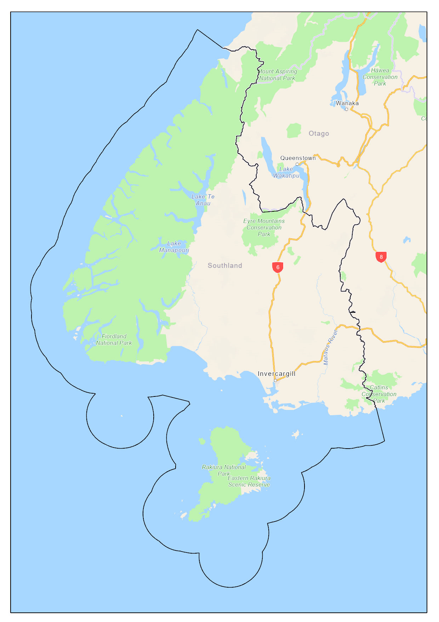

Appendix 2 – Milford Sound Pilotage Area
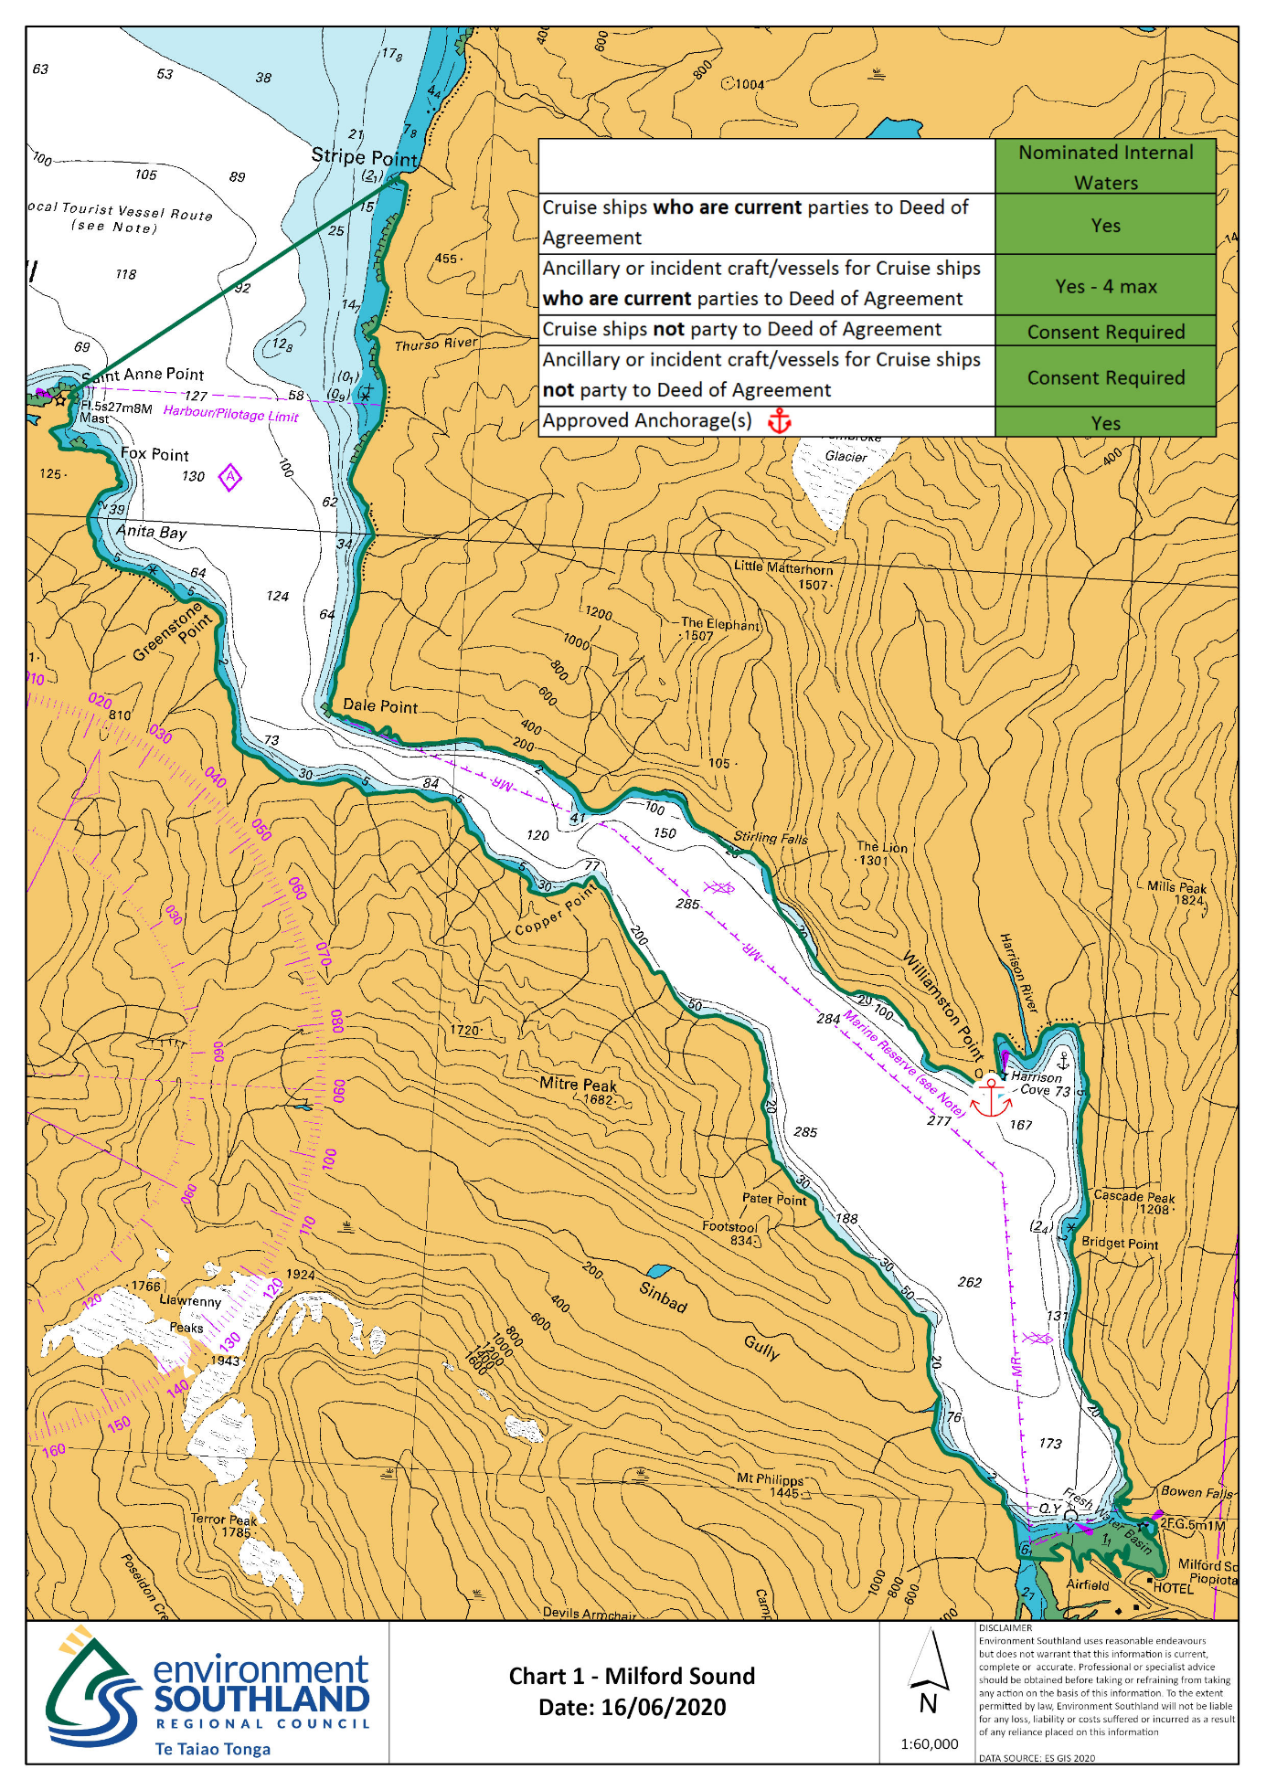
Note: Chart image unsuitable for navigation

Appendix 3 – Thompson/Doubtful Sound Pilotage Area
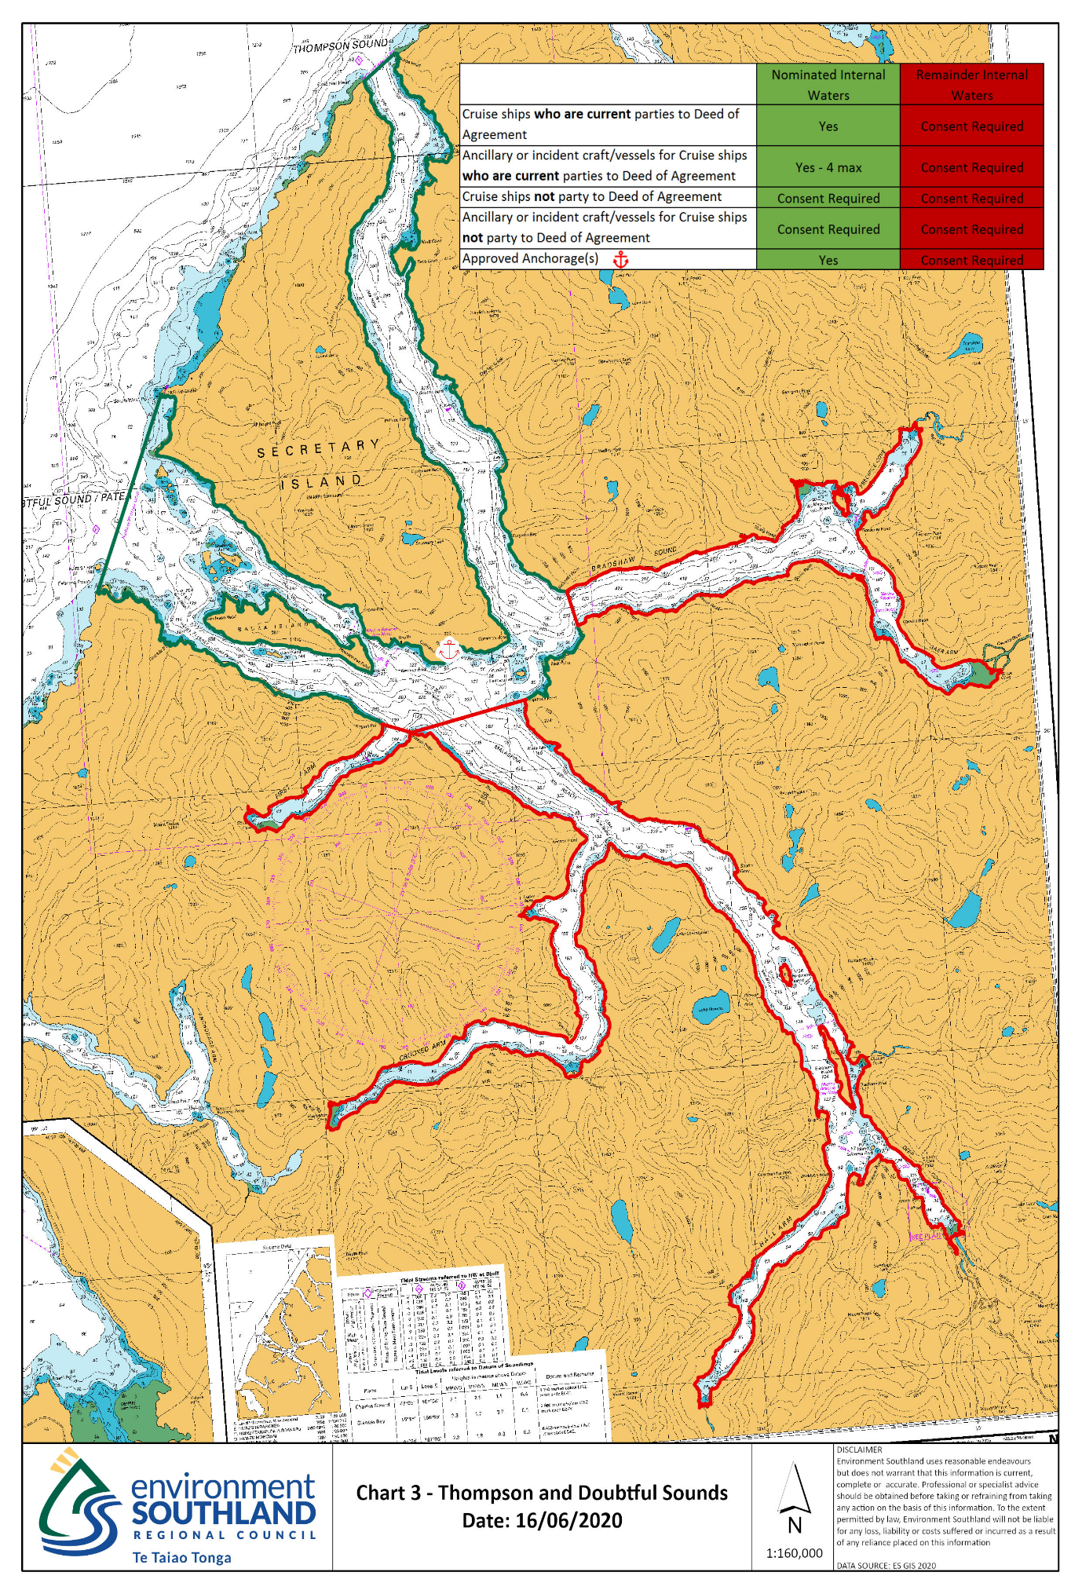
Note: Chart image unsuitable for navigation

Appendix 4 – Breaksea/Dusky Sound Pilotage Area

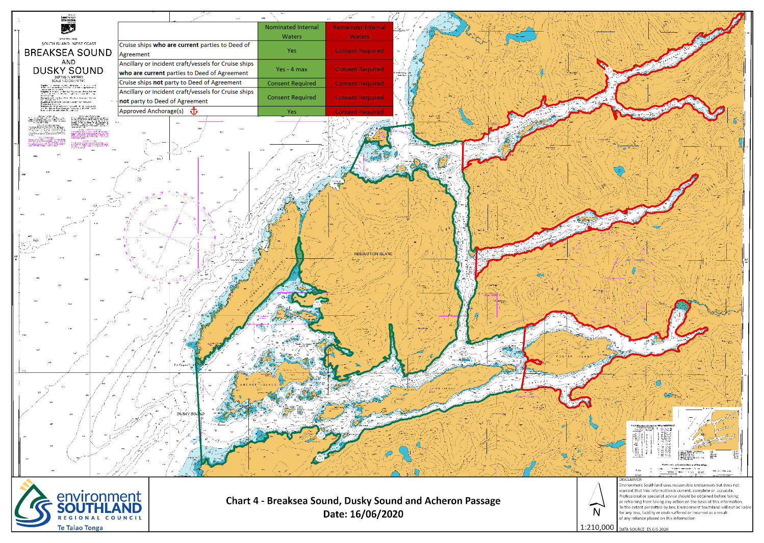
Note: Chart image unsuitable for navigation

Appendix 5 – Stewart Island Pilotage Area

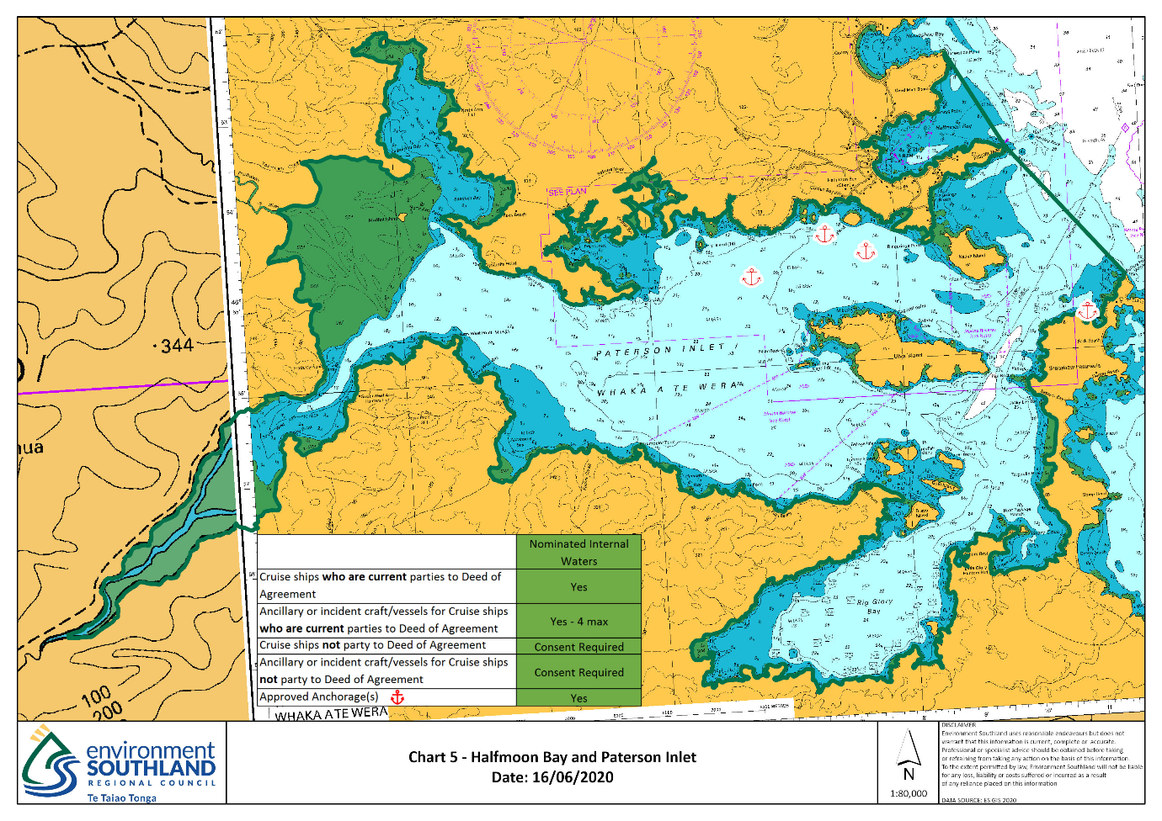
Note: Chart image unsuitable for navigation

The seaward limit of the territorial sea is approximately 12 nautical miles from shore. More precise limits may be found on the website of Land Information New Zealand (LINZ).
All berths, wharfs and channels within pilotage areas are assessed within an international standard for the maximum size of vessel permitted to navigate within them (swing circle 1.8 x vessel length, channel 3 x maximum beam, minimum under keel clearance (UKC) 10% draft). The criteria in 6.3 (3)(a) set out the maximum vessel sizes for each area based on the above standard and current control measures as set down in the pilot or pilot exempt master operating procedure.
For the sake of clarity, a “guideline” is a recommendation of best practice that is generally expected to be followed although has a reasonable allowance for pragmatic flexibility within the bounds of the exercise of sound professional judgement. This is to be compared with a “procedure”, which must be followed except in extenuating cases where the express permission of the Harbourmaster for any requested deviation from the procedure has been granted.
All Pilot Licences and Pilotage Exemption Certificates are subject to annual currency requirements. These include medical fitness; ongoing training; assessment by a Pilot; and a number of local transits.

